**P-TRACKCHAIN: DECENTRALIZED APPLICATION ON AUTOMOTIVE SUPPLY CHAIN**

**MSc 4th**

**SEM, YEAR: 2019-2020**

**DEPARTMENT: COMPUTER SCIENCE AND TECHNOLOGY**

**GROUP MEMBERS:**

1. **DEBANWITA DUTTA(ROLL NO: C91/CSC/181007)**
2. **TRISHITA MUKHERJEE(ROLL NO: C91/CSC/181032)**

**ACKNOWLEDGEMENT**

In performing our assignment, we had to take the help and guideline of some respected persons, who deserve our greatest gratitude. The completion of this assignment gives us much pleasure. We would like to show our gratitude to **Professor Sanjit Setua,** for giving us a good guideline for our research project throughout numerous consultations. We would also like to expand our deepest gratitude to all those who have directly and indirectly guided us in writing this assignment.

Many people, especially our classmates and team members itself, have made valuable comment suggestions on this proposal which gave us an inspiration to improve our project. We thank all the people for their help directly and indirectly to complete our assignment.

**CONTENTS**

|  |  |  |
| --- | --- | --- |
| **Sl.**  **No.** | **TOPICS** | **PAGE NUMBER** |
| **1.** | **Introduction** | **4-5** |
| **2.** | **Automotive Supply Chain Management** | **5-20** |
| **3.** | **Blockchain Technology** | **20-34** |
| **4.** | **Blockchain on AutomotiveSupply Chain**  **Management** | **34-41** |
| **5.** | **Overview on Ethereum Decentralized Application** | **41-43** |
| **6.** | **Ethereum Installation Components** | **43-44** |
| **7.** | **Implementation and Results** | **45-69** |
| **8.** | **Constraints** | **69-70** |
| **9.** | **Discussion** | **70-73** |
| **10.** | **Conclusion** | **73-74** |
| **11.** | **References** | **74-77** |

**1 INTRODUCTION**

Blockchains are regarded as public (and lately also private) ledgers containing transactionaldata within their decentralized data structures, which form a series of tightly connected blocks. Asymmetric cryptography and distributed consensus algorithms are being deployed for achieving ledger consistency, data integrity, auditability, non-repudiation, and authentication as part of the basic security primitives [1]. The distributed and decentralized nature of blockchains makes them

immutable in the sense that transactions cannot be tampered once they are officially validated by the peers of the network and registered in the block of the chain. At the same time, reliability and robustness are ingredients that constitute blockchains as highly trusted platforms implemented on open, trustless networks of peers.

During the last years, we experience significant research and development efforts utilizing blockchains in financial services such as digital assets and payment systems [1,2], smart contracts [3], logistics [4] Internet of Things (IoT) [5,6], and reputation systems [7,8]. This is mainly due to the fact that blockchains can allow transactions and payments to be implemented without any intermediary, thus effectively disrupting the way traditional businesses are working to date.

Logistics and supply chain management are regarded as domains where blockchains are good fits for a series of reasons. During the lifecycle of the product, as it flows in the value chain (from the production to consumption) the data generated in every step can be documented as a transaction creating, and thus, a permanent history of the product. Among others, blockchain technology can

effectively contribute to: (i) Recording every single asset (from product to containers) as it flows through the supply chain nodes, (ii) tracking orders, receipts, invoices, payments, and any other official document, and (iii) track digital assets (such as warranties, certifications, copyrights, licenses, serial numbers, bar codes) in a unified way and in parallel with physical assets, and others. Moreover, the blockchain can contribute effectively, through its decentralized nature, in sharing information about the production process, delivery, maintenance, and wear-off of products between suppliers and vendors, bringing new modalities of collaboration in complex assembly lines.

Any system, in order to achieve traceability, is required for a flow of information that records and follows the flow of products. The interconnected structure of the supply chain makes it difficult to introduce a centralized system in control of a third party, since a high level of trust is required. The limited amount of trust concludes in separate systems that restrain the possibility to accomplish traceability throughout the full supply chain. In today’s world, supply chains end up to be complicated structures with multiple involved participants and with a plethora of activities. Security and organizational issues tend to enhance the need to build a supply chain management system leveraging blockchain ledger technology.

Regardless of the particularities of the specific supply chain related application, blockchain can offer a wide set of advantages. By registering and documenting a product’s lifecycle across the supply chain nodes increases the transparency and the trust of the participating actors. Moreover, elimination needs to have a trusted third party that can allow for greater scalability, as any number of participants

can virtually participate in the chain with the appropriate level of trust, and increased innovation by deploying the dynamics of blockchains as enablers of instant payments (through cryptocurrency), smart contracts, and low transaction fees without having the cost overheads of third parties. Last, but not least, a shared, immutable ledger with codified rules can potentially eliminate the audits required

by internal systems and processes.

While today we experience various research efforts on the analysis of the blockchains in logistics and supply chain management and the adoption of distributed ledger technologies and smart contracts, there has been no detailed methodological approach on what elements of the blockchain are effecting the particular stakeholders and what are the blockchain technical features that someone has to pay special attention to for the wider real-life blockchain adoption in the related business domain. At the same time, some high level conceptual considerations on a blockchain based architecture for the supply chain management is missing and needs to be the subject of further discussions so as to have a reference blueprint for a potential further articulation with the legacy systems owned by the related supply chain stakeholders.

**2AUTOMOTIVE SUPPLY CHAIN MANAGEMENT**

**2.1 What is Supply Chain ?**

A supply chain is a network between a company and its supplier to produce and distribute a specific product to the final buyer. The pace of change and the uncertainty about how markets will evolve has made it increasingly important for companies to be aware of the supply chains they participate in and to understand the roles that they play. Those companies that learn how to build and participate in strong supply chains will have a substantial competitive advantage in their markets.

A good supply chain is basically a group of independent organizations connected together through the products and services that they separately and/or jointly ass value in order to deliver them to the end customer.

The entities in the supply chain include producers, vendors, warehouses, transportation companies, distribution centers and retailers. The functions in a supply chain include product development, marketing ,operations, distribution, finance and customer service[50].

**2.2 What is Supply Chain Management?**

Supply Chain Management is the coordination of production, inventory, location and transportation among the participants in a supply chain to achieve the best mix of responsiveness and efficiency for the market being served.

The main objective of the supply chain management is to monitor and relate production, distribution and shipment of products and services. This can be done by companies with a very good and tight hold over internal inventories, production, distribution, internal productions and sales[46].

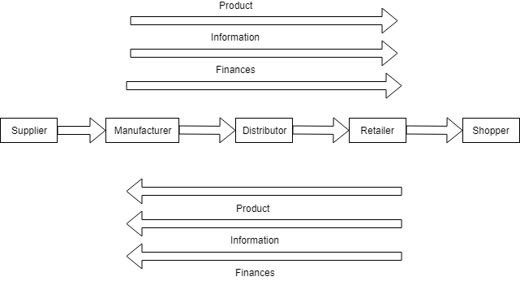

**FIG:1**

**2.3 Dimensions of Supply Chain Management:**

There are 3 major supply chain dimensions---

1. Long Term Relationship:

The key signs of long term relationship in supply chain management are trust and communication. Long term relationships are identified as a very important dimension of SCM. Organizations should be all the time aware of the long term relationships b/w them and other firms. Long term relationship really helps an organization by sharing their knowledge with others and learning from others experience and knowledge.

1. Concurrent Engineering:

It is essentially the collaboration of all the stakeholders of a supply chain i.e. suppliers and customers at an early stage. All the stakeholders are included in decision making from the design stage so that there are no miscommunications regarding any aspect of design of engineering. All the work which might have dependencies with other stakeholders is dome by making cross functional teams and involving all the stakeholders in the process of designing the product or the process.

1. Strategic Purchasing:

In today’s era, purchasing is replaced by strategic purchasing. The profits are generated not from the customers but from the vendors or suppliers. Hence purchasing is becoming more and more strategic now. Identifying the vendor is also a part of strategic purchasing. Strategic purchasing always takes a long term view in mind while taking any decision. The purchasing strategy should be well aligned with the firm’s strategic goals[51].

**What is Logistics?**

Logistics is the process of planning and executing the efficient transportation and storage of goods from point of origin to the point of consumption. Logistics is widely known as the process of coordinating and moving resources such as equipment , food, liquids, inventory , materials and people from one location to the storage of the desired destination. It was originally a military-based term that was used to describe how military force obtained, stored and moved equipment and supplies[52].

**2.4 Difference between Logistics and Supply Chain Management?**

There is a difference b/w the concept of supply chain management and the traditional concepts of logistics. Logistics typically refers to the set of activities that occur within the boundaries of a single organization and supply chain refers to the networks of companies that work together and coordinate their actions to deliver a product to market.

Traditional logistics focuses its attention on activities such as procurement, distribution, maintenance, and inventory management . Supply chain management acknowledges all of its traditional logistics and also includes activities such as marketing, new product development , finance and customer service.

Logistics management is about planning, implementing the forward-reverse flow and storage of goods with related information b/w source and destination. The ultimate aim is to meet the customer’s demand. It involves inbound and outbound logistics, warehousing, materials handling , demand fulfillment , network design and inventory management . Managements encapsulates activities with other functions including marketing , operations , finance and information technology.

Supply chain management, on the other hand is about the integration of supply and demand management within and across all functions in any organizations[53].

**2.5The SCOR Model for Supply Chain Strategic Decisions:**

The supply chain operations reference model (SCOR) is a management tool used to address, improve, and communicate supply chain management decisions within a company and with suppliers and customers of a company . The model describes the business processes required to satisfy a customer’s demands. It also helps to explain the processes along the entire supply chain and provides a basis for how to improve those processes[54].

Plan :

Demand and supply planning and management are included in this first step. Elements include balancing resources with requirements and determining communication along the entire chain. The plan also includes determining business rules to improve and measure supply chain efficiency. These business rules span inventory, transportation, assets, and regulatory compliance, among others. The plan also aligns the supply chain plan with the financial plan of the company.

Source :

This step describes sourcing infrastructure and material acquisition. It describes how to manage inventory, the supplier network, supplier agreements, and supplier performance. It discusses how to handle supplier payments and when to receive, verify, and transfer product.

Make :

Manufacturing and production are the emphasis of this step. Is the manufacturing process make-to-order, make-to-stock, or engineer-to-order? The make step includes, production activities, packaging, staging product, and releasing. It also includes managing the production network, equipment and facilities, and transportation.

Deliver :

Delivery includes order management, warehousing, and transportation. It also includes receiving orders from customers and invoicing them once product has been received. This step involves management of finished inventories, assets, transportation, product life cycles, and importing and exporting requirements.

Return :

Companies must be prepared to handle the return of containers, packaging, or defective product. The return involves the management of business rules, return inventory, assets, transportation, and regulatory requirements .

Benefits of Using the SCOR Model :

The SCOR process can go into many levels of process detail to help a company analyze its supply chain. It gives companies an idea of how advanced its supply chain is. The process helps companies understand how the 5 steps repeat over and over again between suppliers, the company, and customers. Each step is a link in the supply chain that is critical in getting a product successfully along each level. The SCOR model has proven to benefit companies that use it to identify supply chain problems. The model enables full leverage of capital investment, creation of a supply chain road map, alignment of business functions, and an average of two to six times return on investment .

**2.6 Supply Chain Management Decision Areas:**

There is a basic pattern to the practice of supply chain management. Each supply chain has its own unique set of market demands and operating challenges and yet the issues remain essentially the same in every case. Companies in any supply chain must make decisions individually and collectively regarding their actions in 5 areas:

1. Production : What products does the market want? This activity includes the creation of master production schedules that take into

account plant capacities , workload balancing, quality control and equipment maintenance.

1. Inventory: What inventory should be stocked at each stage in a supply

Chain? How much inventory should be held as raw materials , semifinished or finished goods? The primary purpose of inventory is to act as a buffer against uncertainty in the supply chain. However, the holding inventory can be expensive, so what are the optimal inventory levels and reorder points?

3) Location :Where should facilities for production and inventory storage be located ? Where are the most cost efficient locations for productions and for storage of inventory? Should existing facilities be used or new ones built? Once these decisions are made they determine the possible paths available for product to flow through for delivery to the final consumer.

4) Transportation: How much data should be collected and how much

data should be shared and how much information holds the promise of better coordination and better decision making. With good information people can make the decisions about what to produce and how much , about where to locate inventory[55].

The sum of these decisions will define the capabilities and effectiveness of a company’s supply chain. The right combination of responsiveness and efficiency in each of these drivers allows a supply chain to “increase the throughput while simultaneously reducing the inventory and operating expense”.

An example of Extended Supply Chain is explained in FIG:2.

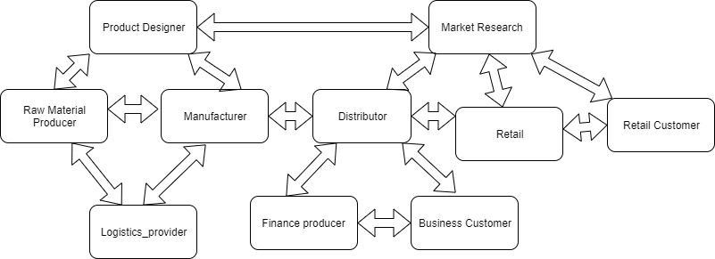

**FIG:2 Example of Extended Supply Chain**

**2.7 A brief on Automobile Supply Chain :**

What is Automobile Supply Chain ?

Automotive industry has hundreds of suppliers and thousands of spare parts units. The industry has been exploring innovative methods to reduce operating cost, lead time and inventory to sustain their growth in the market.

In automobile industry as the manufacturers design and build vehicles globally , their supply chains become increasingly complex with challenges that often stand in the way of profitability and higher shareholder value such as long order-to-delivery lead times, unreliable production schedules, excess inventory across the supply chain , lengthy demand planning cycles and lack of visibility of suppliers[56].

* Sales Forecasting aggregates all the dealers and national sales companies’ forecasts and uses them as an input for production programming. The method is bottom-up approach.
* Production programming is the process of consolidating forecast market demand to available production capacity to get the framework that defines how many vehicles will be built in each factory.
* Order entry is the stage in which orders are checked and entered into an order bank to await production scheduling.
* Production scheduling and sequencing fir orders from the order banks into production schedules These orders are used to develop the sequence of cars to be built on the scheduled date . Supplier scheduling is the process whereby suppliers receive forecasts at various times , actual schedules and daily call-offs.
* Inbound logistics are the process of moving components and parts from supplier to assembly plant.
* Vehicle production is the process of welding, planting and assembling the vehicle.
* Vehicle distribution is the stage at which the finished vehicle is shipped to dealers.
* Order entry begins when a salesperson enters a customer order into the system . Then the order is passed on from the dealer to the national sales/regional sales office and subsequently to the manufacturer’s headquarters.
* An allocation check is dome at the national sales company to see if the desired vehicle is available or not for the dealer.
* Then, a build-feasibility check, which is the process of checking whether the special options and specifications are feasible for the production, follows to determine whether special options and specifications are available for that vehicle in the market. If not, the system rejects the order and the dealer must make the necessary order correction. Bill-Material-Conversion is the process of converting the orders received from the dealer to bill of materials.
* Bill-of-Material-Conversation is the process of converting the orders received from the dealer to a bill of materials. This tells the manufacturers what kind of components they need to build the vehicle.
* The final stage in order entry is to transfer the order as a bill of material to the order bank. The order will stay in the order until the system transfers it into the plant’s production schedule.

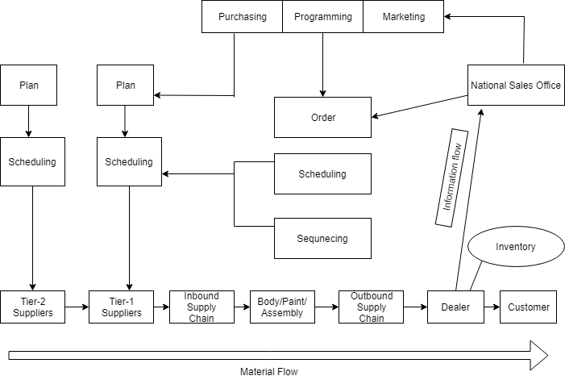

**FIG:3 FLOW OF AUTOMOTIVE SUPPLY CHAIN**

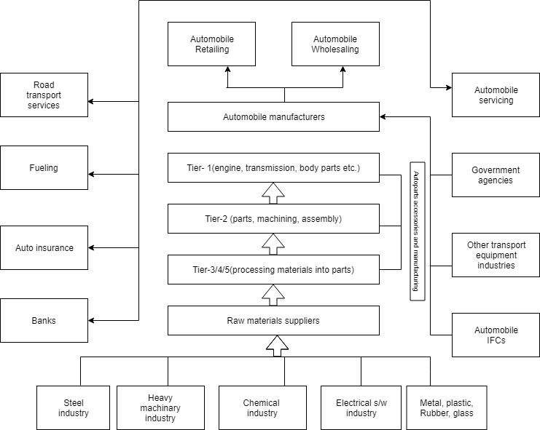

**FIG:4 AUTOMOBILE SUPPLY CHAIN**

**2.8 Supply Chain Challenges :**

1. **Customer Service and Quality Product :** Supply Chain management is all about providing the right product in the right quantity to the right place and the right time. The pressure on manufacturers to produce the high-quality products that are safe is an increasing challenge. The number of product recall cases is growing each day. It can damage a company’s reputation and is expensive to its bottom line.
2. **Supplier / Partner relationship management :** It is important to create, understand and follow mutually agreed upon standards to better understand current performance and opportunities for improvement. Having two different methods for measuring and communicating performance and results wastes time and effort. Trust the system that was put in place for consistent results and better supplier/partner relationships. By creating a mutually sound and harmonious relationship with our partners or suppliers , you will be able to provide your customers with products of high standards in a timely manner. This also allows us to create opportunities for improvement in terms of performance.
3. **Shorter lead time , less inventory and better throughput** : With shorter product life cycles and changing market demands, companies are forces to embark on a lean journey. It is important to note that the supply strategies in a lean environment support the operations strategy . The challenge is always to find not just a lean concept , but a working lean solution.
4. **Cost control :** Operating costs are under extreme pressure by rising energy / fuel and freight costs, greater number of global customers, technology , increasing labor rates and new regulations and rising commodity prices.
5. **Globalization of manufacturing operation :**With the globalization of manufacturing operations, having a global procurement network that can support and react to your supply chain needs is important. Selecting a strategic supplier that provides manufacturing locations with consistent global quality and a reliable local service is a challenge.
6. **Supplier base consolidation:** Consolidation of the supplier base can bring many advantages. It eliminates supply base variances and overheads , especially in the supply of C-parts. The challenge is to find a supplier with solutions and experience in supplier-based consolidation process.
7. **Risk management :** Due to the constant change in the market, coming from a variety of sources such as consumer demands, political agendas and global sourcing , would cause major issues to the operations.
8. **Unforeseen Delays**: Procurement of materials and products may be easy, but the delivery may not always be 100% on time, especially with time differences and a variety of shipping time frames. When items are sourced from different countries , delays like this are very common.
9. **Fast-Changing Markets** : With technological advancements changing our markets everyday, it is quite difficult to stay in pace and adapt to the variety of innovations in the market. But because the goal is to stay efficient in these changing times, companies would have to be more flexible.

**2.9 Solutions of Supply Chain Challenges :**

1. **Safety and quality products :** High quality starts with selecting the correct raw materials , deciding on the right production method according to international standards and finally testing and providing it. Europe, America and Asia, along with their cutting-edge measuring and testing equipment, ensure reliable quality assurance and flawless production quality.
2. **Supplier/ partner relationship management :** By building a strong working relationship with our supplier, you would be able to work efficiently and come up with a better output in a short period of time.
3. **Shorter lead time , less inventory and better throughput :**With a service for design and process optimization that focuses on boosting manufacturing productivity and lowering the Total Cost of Ownership . Value Stream analysis and it provide a full report of our findings and recommendations.
4. **Cost control :**The best solution to this issue would be improving your cost control by executing our plans efficiently through constant monitoring. Through efforts in providing warehouse efficiency we would able to do so.
5. **Supplier base consolidation:** Starting from automatic order placement at one central point a complete concept to streamline the purchasing of all C-parts are produced. In short, C-parts manage themselves.
6. **Risk management :** A risk management plan must be prepared, on how a company will be able to overcome disruptions during the course of operations. By hiring logistics software development company we would be able to manage these issues effectively with less effort on our end. After all , logistics management is vital to the entire operation.
7. **Unforeseen Delays:** Through an efficient warehouse management system we are able to know when we need to have certain materials delivered as well as create a time cushion in terms of delivery to make sure everything runs smoothly.
8. **Fast changing markets**: Change is inevitable. The way we adapt to change is definitely something we need to manage by using logistics management software. We are able to move with the flow and improve our output as a whole[20].

**Use Supply Chain Design Technology to tackle Automotive Industry Challenges:**

1. **Inbound Logistics :** Dedicating time and resources to optimize inbound logistics sometimes takes a back seat to outbound logistics efforts. Controlling the inbound transportation network and evaluating alternate network designs can reduce costs, improve service times and minimize asset usage.

There are few examples of how automotive manufacturers and

suppliers have leveraged supply chain design technology to create

efficient inbound supply chains.

1. **Facility Selection** : Sourcing decisions are some of the most vital ones automotive manufacturers face. By using modeling technology, companies can make supplier and manufacturing location decisions that are optimized across the entire supply chain, identifying the tradeoffs across all the different cost elements.
2. **Transportation route optimization** : This can be dome alone or in conjunction with either supply chain optimization or simulation. Uisng advanced algorithms, transportation routes are defined to minimize the cost of inbound shipments, while considering realistic cost and constraint structures .
3. **Product flow-path optimization:** The process of moving products from supply through production and eventually distribution represents myriad choices. The collective set of these choices make up a products flow-path through the supply chain. Modeling all the alternative flow options and using the smart algorithms to determine the best choices takes the guesswork out of these decisions and provides a useful reference in boardroom decisions.
4. **Consolidation center selection and analysis:** For a company with multiple suppliers making different products in a relatively small area , a consolidation center (CC) may be used to combine smaller shipments for fewer larger shipments and reduced transportation costs .Flow path optimization can identify which products/suppliers should go to a CC, and the network optimization can recommend where and how many CCs may be needed.
5. **Facility and Manufacturing :** Demand for different automobiles shift over time to new regions or different quantities , and suppliers and cost structures changes as well. Facility locations and inventory levels should also change to keep in-sync.
6. **Production Footprint :** Modeling the production footprint and analyzing varying scenarios helps a company balance existing capacity with the investment required to add additional production. This may mean investing in additional capacity in certain locations or perhaps completely moving production capacity to other facilities within the network.
7. **Inventory optimization :** Inventory is our insurance against variability in the supply chain , but one of the biggest sources of variability is demand, and demand can be highly unpredictable or very slow moving , as with service parts fulfillment. Inventory optimization recommends end-to-end stocking levels and appropriate ordering behavior after it thoroughly analyzes and automatically classifies the underlying demand patterns.
8. **Network optimization** : Network optimization is often a starting point for companies exploring supply chain design and can identify major improvements in cost, service and sustainability –often leading to total supply chain savings 10 % or more.
9. **Outbound Logistics :** With endless combination of mode , routes and carriers from which to choose , automotive manufacturers are turning to supply chain and transportation network design to simplify outbound logistics decision making. Here are the few examples:
10. **Evaluating new modes, lanes, strategies :** Using modeling technologies, company can identify optimal DC(Distribution Center)-to-customer assignments , determine the ideal mode mix and LTL/FTL (Less Than Truckload / Full Truckload) combination, create a multi-stop delivery or pick-up routes, determine the best utilization of assets , evaluate driver work schedules and even perform service-based greenfield analysis.
11. **Backhaul optimization :**When designing transportation networks, efficiency is the name of the game. Many manufacturers are utilizing backhaul optimization in order to make the most of driver time, assets and fuel. Transportation route planning technology enables companies to design optimal multi-stop routes.
12. **Considering new delivery options :** Should we continue to ship our own products or consider shipping directly from foreign suppliers? For example, a domestic auto-manufacturer could analyze the costs and service times of utilizing the outbound logistics network of Chinese suppliers to deliver direct instead of first shipping to the U.S.

**Pain points in Automobile Supply Chain:**

1. **Multiple ERPs(Multiple Enterprise Resource System) :** Various point-based solutions, multiple enterprise resource planning system(ERPs) and legacy systems located around the globe mean disparate , disconnected data. That results in poor end-to-end supply chain visibility , latency in critical decision-making and overall inefficiency in supply chain operations.
2. **Complex products :** Vehicles and their various parts and accessories are complex. They often have large, deep and varied bills of material (BOMs) and typically have multiple models, trims, options and packages available. Each has intricate and cascading rules to determine required components in an order-specific BOM. Each market offers configurations with different launch dates.
3. **Increased expediting and premium shipping charges :** Failing to have the right parts available in the right place at the right time has resulted in increased expediting and premium shipping charges. That typically means higher inventory levels, tying up scarce capital and leading to higher obsolescence charges.
4. **Inelastic and constrained global supply :** Volume ramp up brings with it significant challenges. While demand is picking up, and companies are responding by increasing their production, suppliers are still cautious. Accurate demand forecasting for products and associated parts is a struggle.
5. **Large scale data requirements:** The computing power required to model global, multi-tier supply chains and explode demand and supply across integrated supply chains is enormous. But the ability to scale is a critical capability to supply chain success.

**3 BLOCKCHAIN TECHNOLOGY**

**3.1 What is Blockchain ?**

A decentralized computation and information sharing platform that enables multiple authoritative domains, who do not trust each other, to cooperate, coordinate and collaborate in a rational decision making process.

A Blockchain is “an **open**, **distributed ledger** that can record transactions b/w two parties **efficiently** and in a **verifiable** and **permanent** way.

* ‘open’ : accessible to all
* ‘Distributed or Decentralized’ : no single party control
* ‘efficient’ : fast and scalable
* ‘verifiable’ : everyone can check the validity of information
* ‘permanent’ : the information is persistent.

Blockchain can be described as a data structure that holds transactional records and while ensuring security , transparency and decentralization[47].

**3.2 What does Blockchain constitute?**

A Blockchain is a chain of records called blocks that are linked and secured using cryptography. Each block has the following key components: data, hash, previous hash and metadata (timestamp, block number).

* Data in a block could be a simple string such as “Blockchain Data Structure” or a list of transactions.
* Hash is a unique identifier for a block and is analogous to a fingerprint for a human. Hash = function(data, previous hash, metadata)
* Previous hash is the hash value of the previous block in the blockchain.
* Metadata is the information about data i.e. block number, timestamp etc.

The key benefit of blockchain solution is its ability to brig trust among parties that do not know and trust each other while offering data integrity ,openness and decentralized structure.

**3.3Properties of Blockchain:**

1. **Decentralized system :** Decentralized technology gives us the power to store our assets in a network which further access by means of the internet, an asset that can be anything like a contract, document etc. Through this owner has a direct control over her account by means of a key that is linked to her account which gives the owner a power to transfer her assets to anyone she wants.
2. **Immutability :** Immutability means something that can not ne changed or altered. This ensures a permanent, unalterable network. Any database that is centralized is subjected to get hacked and they require trust in the third party to keep the database secure.
3. **Enhanced security** : As it gets rid of the need for central authority , no one can just simply change any characteristics of the network for their benefit. Using encryption ensures another layer of security for the system. Every information on the blockchain is hashed cryptographically. The information on the network hides the true nature of the data. For this process, any input data gets through a mathematical algorithm that produces a different kind of value , but length is always fixed.
4. **Irreversible / Tamper Proof :**Hashing is quite complex and it is not computationally easy to alter or reverse it . No one can take a public key and come with the private key. If someone wants to corrupt the network, he/she would have to alter every data stored on every node in the network. There could be millions of people and everyone has the same copy of the ledger. Accessing and hacking millions of computers is next to impossible and costly[48].

**So, the features of the Blockchain are:-**

* **Less failure :** As Blockchain operations does not depend on the human calculations ,it is highly fault-tolerant.
* **Less prone to breakdown:** As decentralization is one of the key features of the blockchain technology, it can survive any malicious attack because attacking the system is more expensive for hackers and not an easy solution.
* **No third-party :** Decentralization nature of this technology makes it a system that does not rely on third party companies.
* **Transparency :** The decentralized nature of the technology creates a transparent profile of every participant. Every change on the blockchain is viewable and males it more concrete.
* **Authentic nature :** Blockchain provides authenticity by using cryptographic hash functions and also generates a unique certificate for each and every participant ion the network.
* **Consensus :** Every blockchain has a consensus to help the network to make decisions. Consensus is a decision-making process for the group of nodes active on the network. Here the nodes can come to an agreement quickly and relatively faster. When millions of nodes are validating a transaction, a consensus is absolutely necessary for a system to run smoothly. It is a kind of voting system, where the majority wins and the minority has to support it. The consensus is responsible for the network to be trustless. Nodes might not trust each other but they trust the algorithms that run at the core of it.

**3.4Public Blockchain vs Private blockchain :**

**Public / Permission less :**

Anyone can join the Blockchain network, this means that they can read, write, or participate with a public blockchain. Public blockchain are decentralized and no one has control over the network and they are secure in that data cannot be changed once validated on the blockchain.

**Private / Permissioned:**

Permissioned networks place restrictions on who is allowed to participate in the network and in what transactions. Most of the time, private blockchains tend to come with identity management tools or a modular architecture, where we can plug in our own identity management solution. This can be anything from a Membership Service Provider to an OAuth solutions using Google, Facebook etc.

|  |  |
| --- | --- |
| Public | Permissioned |
| Open, anyone can join the network | Restricted and permissioned, a new member joins the network via invitation |
| Each Node has equal transmission power (Distributed) | Only certain nodes can create new transactions |
| Low speed of transaction accomplishment | Fast speed of transaction accomplishment |
| Long transaction approval frequency | Short transaction approval frequency |
| High cost of each transaction | Comparative cheap cost of each transaction |
| Proof-of-work, Proof-of-stake consensus for the adding on a new block | Pre-approved participants adding of a new block |
| Anonymous | Anonymous |
| Require no trust among the members | Members need to trust each other |
| Large energy consumption | Low energy consumption |

**3.5 Suggested Architecture and Blockchain Approach:**

**3.5.1 Overview and Assumptions:**

Due to the high number of stakeholders involved in large scale supply chains of global range, the relationships between them end up to be complex. Modern supply chain management carries many trust-based concerns that constitute the main cause why a blockchain solution is essential and seems mandatory. First of all, there exists a lack of trust among the participants of a supply chain. Every party

needs to trust that true data is issued and exchanged by another party in their intercommunication. Unfortunately, this does not occur in contemporary supply chains where freight failure, human error, or intended fraud prospers. Furthermore, it is essential that such systems need to effectively gather valid data, record it securely and provide exact information to several other systems. Failures on these

processes occur frequently and, as a result, a global end-to-end supply chain system depends highly on its fragile links that slow down, alter or impede information flow. In addition, lack of both high standards and end-to-end integration leads to information inconsistency among stakeholders. Each party needs to collect and confirm the data validity in order to ensure integrity and effectiveness that decreases system performance. Additionally, limitations on the efficient information flow manipulation exist due to the current supply chain system structure. Due to the complex architecture, the system is additionally changed with hard tasks such as product traceability and monitoring that crucially

impair performance and efficiency. For example, tracking the complete system starting from raw material extraction to factory-produced ware ready to be purchased has become a significantly complex procedure in modern supply chains.

Supply chains will benefit from blockchain innovative science through numerous ways. Blockchain will essentially contribute to transparency and auditability that will support large extent freight conditions violations and human error and fraud detection (the cost of global fraud was evidenced in a report by PwC [37], where it is indicated that 49% of organizations globally said they have been a victim of fraud and economic crime). Product conditions will be controlled and reported on the ledger when they overcome the proper thresholds, as well as any human error that could damage the goods of the chain’s procedures. In order to reduce reputation risks, human rights, and conduct codes will be respected along the chain by being recorded on the ledger. Intended fraud will be detected and reported on the blockchain as a transaction as well, while notifications and messages could be broadcasted inside the blockchain network in order to inform other parties about the participant that tried to commit fraud. Additionally, blockchain will provide continuity of information through its well-known properties of immutability and irrevocability. Secure sharing of data between different stakeholders that participate in a global supply chain will be essential in order to guarantee freight traceability and reduce the risk of errors or frauds and will easily be implemented

inside a public or permissioned blockchain network that ensures trustless party intercommunication and tamperproof data. Further, properly authorized accessibility to information will be achieved with important benefits for future references. Agile and transparent blockchains will offer access to ledger data retrospectively in order to benefit from the massive volume of the information produced.

**3.5.2 Blockchain Ledger Layer**

The Blockchain Layer of the architecture describes its core low-level blockchain network functionalities. The modules that constitute this layer are mainly for achieving consensus among the peers and manage the transactions that are going to be registered in the ledger. The Consensus Module confirms data authenticity and the proper execution of operations inside the blockchain network. It is responsible for transactions validation and verification and the overall agreement on current ledger state among different nodes that participate in the blockchain network.

This module is directly connected with the Transactions Handling module of the Blockchain Layer and they all together form the blockchain data structure. Permissioned blockchain platforms utilize new consensus protocols in contrast with public blockchains that use traditional ones. Algorithms for permissioned blockchains tend to reach consensus faster and more efficiently in a private environment. In order for the different peers of a blockchain network to co-operate and agree on the validity of the transaction data, a protocol needs to be adopted. This is the responsibility of a consensus algorithm that offers trust-less node interaction and decentralized applications implementation inside

a blockchain network. The Transactions Handling Module is another core blockchain network module. Its main responsibility is to store the transaction data on the blockchain ledger. It is directly connected with the previously mentioned Consensus Module of the Blockchain Layer together forming the blockchain data structure. The two modules interact with each other and together communicate with the Middleware Layer as a whole blockchain scheme. When a transaction is being submitted to the blockchain network, all of its information is recorded on the ledger. Data such as the transaction hash, the address of the sender, the address of the receiver, the timestamp, the value of the transaction and other information are grouped and committed on the ledger. The Transactions Module is absolutely necessary in order to properly handle and forward this information of any happening transaction inside the blockchain network.

**3.5.3 Middleware Layer**

The “Middleware Layer” is the core layer of the infrastructure since it is the substantial connecting tier between the Blockchain Layer and the top layers that are closer to the supply chain management such as Enterprise Resource Planning (ERPs) and other related software packages. The Middleware Layer each consists of the following modules:

Upload Handler: The “Upload Handler” regulates document uploading such as e-invoices, receipts or other official documents associated with every step of the value chain. When a new document (e.g., e-invoice) needs to enter the infrastructure, certain operations need to be followed in order to handle it and guide it through the architecture. The Upload Handler module interacts with

the top layers (Application Layer) through appropriate APIs for controlling and managing the initial uploading of information. For instance in order to upload an e-invoice a smart contract is created and deployed through the “Smart Contract Manager” module. After that, the e-invoice is stored on thecorresponding distributed data storage, as described on the “Data Orchestrator” module below.

Data Orchestrator: The “Data Orchestrator” Module is responsible for storing efficiently an e-invoice in a secure distributed manner with low latency. Highly distributed storage and file systems are very suitable for such implementations and approaches such as the Interplanetary File System (IPFS) [38]. This module retrieves and stores securely the e-invoice, either ‘Required’ or ‘Paid’, provided

from the Upload Handler module.

Smart Contract Manager: The Smart Contract Manager is a crucial module of the Middleware Layer since most operations go through its functionalities and approval mechanisms. The automatic creation, deployment, and triggering of smart contracts constitute its main responsibility. It is a module with core functionalities that interacts with the Upload Handler and the Transactions Handler. When a merchant or customer is uploading an e-invoice, either ‘Required’ or ‘Paid’, the Smart Contract Manager processes the respective inputs collected from the Upload Handler (sender and receiveraddresses, e-invoice due date and value, and other e-invoice information) and creates a new smart contract. After that, the module deploys it to the blockchain network through the Transactions Handler. If a ‘Required’ e-invoice is uploaded, this new smart contract emits an event inside the blockchain network in order to trigger a customer’s smart contract that eventually informs their ERP that they need to pay this ‘Required Invoice’.

Application level Transactions Handler: This module regulates transactions managing inside the supply chain management infrastructure of the participating actors and is responsible for all the interactions between the Application level and Middleware Layer. It can be regarded as the external Application Programming Interface (API) with the middleware services that need to further process this request to the blockchain ledger. Interacting with the Smart Contract Manager module is also foreseen as many times the different transactions are going to be bound to specific conditions imposed by the smart contract upon which they are based. As clearly explained previously in the Smart Contract Manager, every smart contract related functionality creates a new transaction that is controlled by the

Transactions Handler and forwarded to the Blockchain Layer.

Figure 5 illustrates information about the integration of blockchain technology and supply chain by introducing a blockchain architecture scheme which handles each product stage with similar respect. As can be seen from the figure, every supply chain stage is approached as a step of the freight journey which is recorded thoroughly on the blockchain ledger. On each step, two parties are engaging together with the blockchain service which automates the procedures of the step, such as submitting any necessary transactions on the ledger. More specifically, on stage n+1 there exists a party that inputs data (party n) and a party that receives the step’s output information (party n+1). This procedure is completely automated through the Middleware Blockchain Service which handles data properly and submits the necessary step transactions on the blockchain ledger. For instance, at the end of the legitimate completion of a particular step, special smart contracts would be triggered in order to distribute payments to custom parties.

On the proposed schema of Figure 5, each party prepares the next step (stage) of the supply chain by confirming the previous one. In particular, the confirmation takes place by inputting the proper hashes and other proof material output from the previous step. After that, custom smart contracts could be triggered depending on the step, and then, the Middleware confirms the validity of the input and initiates next stage’s procedures. Such procedures would be to gather appropriate transaction hashes, tags or electronic seals, and other ledger information of previous steps, as shown in the figure. The Middleware interacts directly with the blockchain ledger and its blocks that include transactions and all the important tamperproof data. Following this, the supply chain step is eventually executed

through the Middleware in an environment that ensures a continuous data validation. After the stage completion, the actions are reported by submitting one or more new transactions on the ledger that includes the appropriate product tags or electronic seals. The new transactions prove in the legitimate circumstances under which the supply chain stage was finished and allow the next stage to be initiated.

The possible case of any product failure, human error or intended fraud will immediately be detected since the appropriate hashes and other crypto material will not match for the next step to get started. Since all values are reported on the blockchain ledger, any mismatch would trigger smart contracts that encounter matters of such kind and would inform both step parties as well as other participants of the whole chain if necessary, for the error. For instance, cold medical bottles’ temperature on a specific truck raised about 40% above the threshold during the transportation, and thus, they are currently useless since they are able to cause serious problems to patients [40].

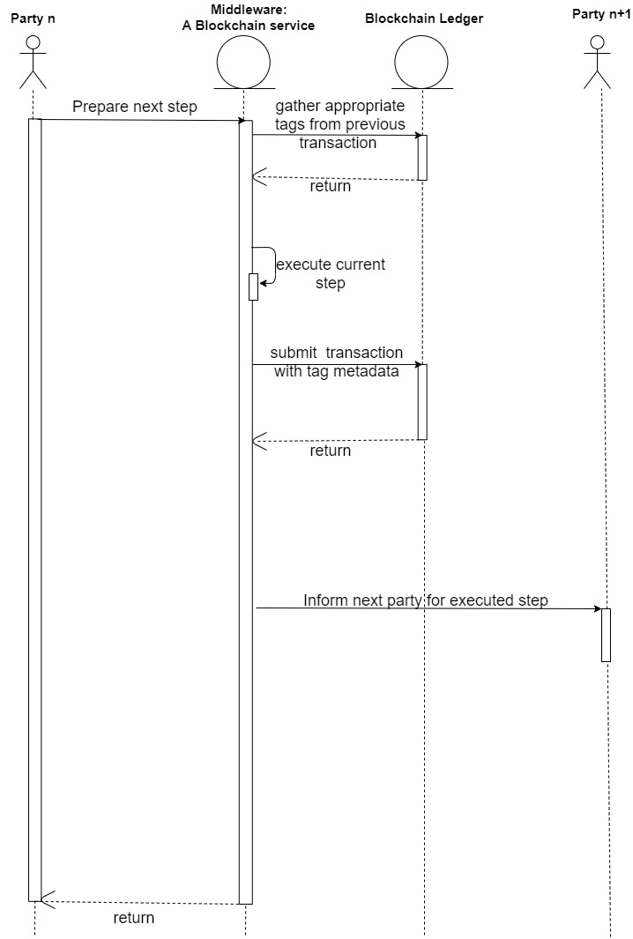

**FIG: 5 One supply chain freight stage (stage number n+1) as a blockchain transaction. Every stage's functionality is automated by the "Middleware", and thus, the parties that participate in each stage (a single one in the input and another one in the output) have a small interaction with it; for instance, Figure 5. One supply chain freight stage (stage number n+1) as a blockchain transaction. Every stage’s functionality is automated by the "Middleware", and thus, the parties that participate in each stage (a single one in the input and another one in the output) have a small interaction with it; for instance, the driver confirms that the transportation was completed by receiving the appropriate transaction hash, or the employee confirms that certain materials were kept refrigerated, as expected, by collecting the corresponding transaction hashes and others. Here, party n participates in stage n+1 input (and already in stage n output) while party n+1 participates on stage n+1 output (and stage n+2 input).**

**3.6 Blockchain consensus protocol:**

The Blockchain consensus protocol consists of some specific objectives such as coming to an agreement, collaboration, co-operation, equal rights to every node, and mandatory participation of each node in the consensus process. Thus, a consensus algorithm aims at finding a common agreement that is a win for the entire network. Thus, the consensus algorithms are:-

1. **Proof of Work(PoW):**

This consensus algorithm is used to select a miner for the next block generation. Bitcoin uses this PoW consensus algorithm. The central idea behind this algorithm is to solve a complex mathematical puzzle and easily give out a solution. This mathematical puzzle requires a lot of computational power and thus, the node who solves the puzzle as soon as possible gets to mine the next block.

1. **Practical Byzantine Fault Tolerance (PBFT):**

PBFT tries to provide a practical Byzantine state machine replication that can work even when malicious nodes are operating in the system.  
Nodes in a pBFT enabled distributed system are sequentially ordered with one node being the primary(or the leader node) and others referred to as secondary(or the backup nodes). Note here that any eligible node in the system can become the primary by transitioning from secondary to primary(typically, in the case of a primary node failure). The goal is that all honest nodes help in reaching a consensus regarding the state of the system using the majority rule.  
A practical Byzantine Fault Tolerant system can function on the condition that the maximum number of malicious nodes must not be greater than or equal to one-third of all the nodes in the system. As the number of nodes increase, the system becomes more secure [22].

1. **Proof of Stake (PoS):**

This is the most common alternative to PoW. Ethereum has shifted from PoW to PoS consensus. In this type of consensus algorithm, instead of investing in expensive hardware to solve a complex puzzle, validators invest in the coins of the system by locking up some of their coins as stake. After that, all the validators will start validating the blocks. Validators will validate blocks by placing a bet on it if they discover a block which they think can be added to the chain. Based on the actual blocks added in the Blockchain, all the validators get a reward proportionate to their bets and their stake increase accordingly. In the end, a validator is chosen to generate a new block based on their economic stake in the network. Thus, PoS encourages validators through an incentive mechanism to reach to an agreement.

1. **Proof of Burn (PoB):**

With PoB, instead of investing into expensive hardware equipment, validators ‘burn’ coins by sending them to an address from where they are irretrievable. By committing the coins to an unreachable address, validators earn a privilege to mine on the system based on a random selection process. Thus, burning coins here means that validators have a long-term commitment in exchange for their short-term loss. Depending on how the PoB is implemented, miners may burn the native currency of the Blockchain application or the currency of an alternative chain, such as bitcoin. The more coins they burn, the better are their chances of being selected to mine the next block. While PoB is an interesting alternative to PoW, the protocol still wastes resources needlessly. And it is also questioned that mining power simply goes to those who are willing to burn more money.

1. **Proof of Capacity:**

In the Proof of Capacity consensus, validators are supposed to invest their hard drive space instead of investing in expensive hardware or burning coins. The more hard drive space validators have, the better are their chances of getting selected for mining the next block and earning the block reward.

1. **Proof of Elapsed Time:**

PoET is one of the fairest consensus algorithms which chooses the next miner using fair means only. It is mainly used in a permission Blockchain network where permission is required for accessing the network.  
In this, every individual on the network is supposed to wait for a random amount of time. The participant who has finished waiting for the given set of time will get a chance to be on the ledger to create a new block.

There also exist other consensus algorithms like Proof of Activity, Proof of Weight, Proof of Importance, Leased Proof of Stake, etc. It is therefore important to wisely choose one as per the business network requirement because Blockchain networks cannot function properly without the consensus algorithms to verify each and every transaction that is being commited.

**3.7 Blockchain technology platforms[49]:**

1. The more popular blockchain / distributed ledger systems in **alphabetical order** are:
2. **BigChainDB**- An open source system that “starts with a big data distributed database and then adds blockchain characteristics — decentralized control, immutability and the transfer of digital assets”.
3. **Chain Core**-A blockchain platform for issuing and transferring financial assets on a permissioned blockchain infrastructure.
4. **Corda**-A distributed ledger platform with pluggable consensus.
5. **Credits**, a development framework for building permissioned distributed ledgers.
6. **Domus-Tower Blockchain**, designed for regulated environments, benchmarked at ingesting over 1 million transactions per second.
7. **Elements Blockchain Platform**-An open source, protocol-level technology for extending the functionality of Bitcoin.
8. **Eris:db**-An open source, protocol-level technology for extending the functionality of Bitcoin.
9. **Ethereum**-A decentralized platform that runs smart contracts on a custom built blockchain.
10. **HydraChain**- An Ethereum extension for creating Permissioned Distributed Ledgers for private and consortium chains.
11. **Hyperledger Fabric**- It supports the use of one or more networks, each managing different Assets, Agreements and Transactions between different sets of Member nodes.
12. **Hyperledger Iroha**,-A “simple and modularized” distributed ledger system with emphasis on mobile application development.
13. **Hyperledger Sawtooth Lake**- modular blockchain suite in which transaction business logic is decoupled from the consensus layer.
14. **Multichain**- An open-source blockchain platform, based on bitcoin’s blockchain, for multi-asset financial transactions.
15. **Openchain**- An open source distributed ledger system for issuing and managing digital assets.
16. **Quorum**-An open source distributed ledger and smart contract platform based on Ethereum.
17. **Stellar-**An open-source, distributed payments infrastructure that provides RESTful HTTP API servers which connect to Stellar Core, the backbone of the Stellar network.
18. **Symbiont Assembly**-A distributed ledger inspired by Apache Kafka.

**3.7 Blockchain issues and their solutions:**

**1. Scalability :**

Scalability is truly a trilemma- it is the question of how many transactions can blockchain process without sacrificing either speed, security or decentralization.

As cryptocurrencies spread in the last few years, more and more transactions were recorded on certain blockchains, like Bitcoin or Ethereum, increasing the size of the chain and making computation more resource-intensive. This decreases the mining capability, and keeps the transaction speed low- Ethereum can process about 15-20 TPS, which compared to the 45,000 TPS on the Visa network is not enough for the current world.

**Solution:** Many are trying to solve this issue by either using entirely new blockchain platforms or employing a second layer on existing blockchain applications to increase scalability.

**2. Security :**

As mentioned above, scalability directly affects security issues on a blockchain. There are three major problems we need to consider within security. Firstly, if the majority of validators are corrupt, fraudulent transactions can be added to the blockchain- this is called 51% attack. Secondly, smart contracts can be vulnerable- a wrongly written smart contract can be exploited. Thirdly, private keys, which constitute the only access to cryptocurrency funds, are hard to keep safe, and can not be recovered if lost- resulting in inaccessible assets on the blockchain.

**Solution:** Innovative blockchain platforms and diverse consensus methods are being developed to increase security against malicious nodes taking power. While autonomous, self-executing smart contracts are a high possibility, we need to learn how to use them, write them, and find intersections with legal systems.

**3. Reputation :**

Blockchain suffers from an image problem: in the general public many still fully associate blockchain technology with cryptocurrencies, with high volatility and shady transactions. Blockchain for many is even passing fancy, unreliable technology and just a useless trend. Some others believe blockchain can be applied to anything and will change everything in the world.

**Solution:** There are significant efforts to educate audiences, highlighting the separation of blockchain from cryptocurrencies. With the development of practical use cases and increased communication, a brighter image is forming towards what blockchain can accomplish.

**4. Regulation :**

Blockchain brings a new possibility in many fields- investment, data sharing, and privacy, financial transactions, etc.. The regulatory environment is trying to adapt, but still, many questions remain: how will data on blockchains comply with privacy laws? What will be the regulation on tokenized securities?

**Solution:** Governments around the globe are pushing for better regulations around technology, working with industry professionals to establish a framework suited for blockchains. Countries such as Malta, Israel, and South Korea, to mention a few, have developed an exemplary open approach.

**5. Complexity :**

Blockchain technology is a hard concept to grab- nodes, immutability, smart contracts, cryptography, etc.. None of these are easy to understand. Moreover, the user experience of blockchain applications has not been perfected yet- many applications are complicated to use and understand.

**Solution:** Education is crucial for blockchain technology in a friendly, understandable way. This is our main mission with Flash Learn. Secondly, blockchain applications are striving to reduce complexity, and consider users who do not know in depth technology to use it. At the intersection of these 2 points, we will achieve mass adoption.

1. **Interoperability :**

One of the current issues in the market is the appearance of fierce competition between blockchain platforms.Ethereum , [Waves](https://wavesplatform.com/), [Hyperledger Fabric](https://www.hyperledger.org/projects/fabric), [Stellar](https://www.stellar.org/) and [R3](https://www.r3.com/) Corda, and many more on the market seem to be competing to build better applications. The truth is, these applications have different benefits and will be used in different environments.

**Solution:** building cooperation and interoperability. Everyone is striving for the same goal- spreading blockchain technology to make our world more effective. The blockchain platforms are starting to communicate with each other, and creating overarching interoperable solutions[31].

**4 BLOCKCHAINON AUTOMOTIVE SUPPLY CHAIN MANAGEMENT**

**4.1 Supply Chain challenges and Blockchain solutions :**

1. **Provenance Tracking :** Keeping track of all the elements in supply chains for big companies and organizations can be tedious. Thus, it becomes very difficult to maintain the record for such multinational corporations. Besides , the lack of transparency can lead to a loss of money with the number of middlemen in the traditional supply chain. This leads to cost and customer relations issues which dilutes the brand name.

In a blockchain-based supply chain management these issues don’t exist because the product information can be easily accessed through the help of embedded sensors and RFID tags. Also, record keeping and data provenance tracking become easy. The history of a product right from its origination to where it is present can be traced through blockchain. Such accurate tracking methods can also help us in detecting frauds in any part of the supply chain. Moreover , improving traceability also adds value by mitigating the high costs of quality problems ,such as recalls , reputational damage or the loss of revenue from black- or grey-market products. Damage and mishandling management is also done by provenance tracking[48].

1. **Cost reductions and replacing slow manual process :** Although supply chains can currently handle large, complex data sets, many of their processes especially those in the lower supply tiers, are slow and rely entirely on paper. The real-time tracking of a product in a supply chain with the help of blockchain reduces the overall cost of moving items in a supply chain. In fact, as per a recent survey, more than one third of people agreed that the reduction of costs is the best benefit of Blockchain for Supply Chain Management. There is no need to carry a bunch papers for the shipment of a particular product from one end to other end in the supply chain.

When Blockchain is applied to speed up administrative process in supply chains, the extra costs occurring in the system are automatically reduced while still guaranteeing the security of transactions. The elimination of the middlemen and intermediaries in the supply chain saves the risks of frauds , product duplicity and saves money too. It also reduces manufacturing and circulation of any fake products apart from the money. Payments can be processed by customers and suppliers within the supply chain by using crypto currencies rather than customers and suppliers rather than relying on EDI. Moreover efficiency will be improved and the risk of losing products will be reduced with accurate recordkeeping[49].

1. **Establishing trust and maintaining integrity** : Supply chains generally have many participants. So, having trust in such huge and complex supply chains with many members is often an issue. For example when a manufacturer shares his products with suppliers , he/she should be able to depend on then for the following facory safety standards. Also, when it comes to regulatory compliances such as custom enforcers, trust plays a vital role. The immutable nature of blockchain in the supply chain is well-designed to prevent tampering and establishing trust b/w different participants. Further, blockchain has the potential to connect different ledgers and data points in a better manner . This helps in maintaining the data integrity among the participants[53].
2. **Contract enforcement and management :** This can be done by using smart contract. A smart contract is a self-enforcing piece of code that is managed by a P2P network of computers, Smart contracts are a client rights management tools that provide a coordination and enforcement in a network for agreements between network participants , without the need of traditional legal contracts. They can be used to formalize simple agreements b/ two parties. It is a self-enforcing agreement embedded in computer code managed by blockchain. The code contains a set of rules under which the parties of that smart contract agree to interact with each other. If and when the predefined rules are met, the agreements is automatically enforced. Smart contracts provide mechanisms for efficiently managing the tokenized assets and access rights b/w two or more parties.
3. **Oversight on Counterfeiting :** Counterfeits result in major financial losses , not only to the manufacturers but they also reduce the general welfare due to missed tax revenue. Counterfeit products might not contain the right active ingredients and therefore be useless to harmful. Blockchain technology removes the need for trusted intermediaries, can facilitate faster transactions and add more transparency. Thus it is possible to reduce the counterfeit products in supply chain using blockchain technology.

**What does Blockchain have to offer to the automotive industry?**

**Blockchain in Car Manufacturing :**

* **Supply Chain Management :** Car parts could be lost in delivery ,stolen, replaced, damaged etc. Blockchain would allow the manufacturer to have a complete follow-up of these pieces. In the case of a recall, blockchain would also facilitate the procedures: since it carries the information on the origin of the piece, we could control if any modifications have been made to it or if a manufacturing detect occurred.
* **Parts provenance :** Duplicate auto parts frequently get into the supply chain. As a result , they often fail as soon as they are installed. This causes damage to the manufacturers, as well as suppliers,. While the conventional tracking system has helped automakers deal with this fraudulence to a certain extent, yet counterfeit parts have always managed to make their way into the supply chain. Blockchain allows the creation of a unique ID for each part, along with immutable timestamps i.e. the time since when the part is developed. To ensure authenticity protection, these tags that link to the blockchain can be set into the parts.
* **Manufacturing processes** : There are numerous opportunities to take advantage of blockchain technology throughout the automotive manufacturing process. We can use blockchain to store the data from bills of lading for vehicle components and quality-inspection records created during the manufacturing process to WIP information for each vehicle assembly from start to finish .
* **Finances :** All processes that require manual data insertion, include transactions or transaction costs as well as revisions , among the other things, could be streamlined. The blockchain would accelerate these processes and keep them updated throughout the lifecycle of a car.
* **Vehicle safety and data security :**The more connected a vehicle is , more susceptible it becomes to potentially deadly cyber attacks. Thanks to blockchain’s strong cryptographic roots that cannot be reverse-engineered, it is perfect place to store data since it cannot be changed.
* **Telematics :**In the connected car space , telematics includes software-based navigation, vehicle-to-vehicle (V2V) communications, and a host of other services that can affect vehicle safety and passenger security. We can use blockchain to keep safe the data sent and received by telematics systems. The heightened level of encryption prevents hackers from viewing or using the data.
* **Smart insurance :** Blockchain technology enables the unmanipulable and transparent logging of vehicle’s sensor data in a decentralized network. This unimpeachable documentation of a blockchain “black box” could help to resolve the circumstances of an accident, especially when it comes to autonomous vehicles. Blockchain could also enable insurances to be taken into other vehicles like a user profile for example in car sharing .
* **Inbound plant logistics:** Ensuring timely distribution if deliverables is essential for ensuring efficiency and transparency across the supply chain. Consequently, manufacturers must co-ordinate effectively with other participants of the inbound chain to provide timely delivery of parts. A blockchain powered system coupled with IoT sensors can provide permissioned supply chain participants with accurate and transparent view of the product quantity , status and other essential information regarding it. This would help OEM(Original Equipment manufacturers) plant manufacturers to plan their production schedule more precisely, improve traceability and streamline the flow of goods. Furthermore, suppliers would be able to optimize inventory , reduce the incidences of lost or wrong order besides reducing cost of warehousing.

**Blockchain for Car owners:**

* **Buying or selling a car:** For car owners, blockchain-based registries would mean easier verification of the vehicle’s history(e.g. whether it has been in an accident) allowing, therefore, major transparency when purchasing a car. Another pro would be having an overview of the parts of the vehicle : the users could look up the origin of the carpets and solve repair-related problems. By using smart contract, seller and buyer could enforce the transaction of goods without the need for a middleman.
* **Vehicle tracking :** Another thing that plagues the automotive supply chain is the unethical practice of selling a showroom vehicle by the car dealer without reporting the sale to the bank that has sanctioned a loan for the same. The money laundered in the process is used by the dealer as a capital to conduit suppliers and payroll. While the Bank can take appropriate action against the dealer if it catches on such incidences, but it usually fails to do so as the vehicle is sold legally and the financing is already spent, leaving banks with no option. To deal with such issues , transparent access to data is required. Blockchain removes all the asymmetry in information and provides instant transparency.

**Blockchain use cases in mobility sector:**

* **Leasing and vehicle financing :** we could optimize and automate various processes in vehicle leasing and financing sector by the help of smart contract. Fir example : if a car’s leasing rate hasn’t been paid yet, it is possible to prevent it from being used by deactivating the unlock system.
* **Carsharing:** Blockchain technology could enable a secure digital identity at carsharing. With blockchain, personal settings and preferences could be saved in the car safety avoiding exposure to unnecessary parties. This could also be enable P2P carsharing. Meanwhile, blockchain could facilitate the carsharing procedure for the users as a single registration in the blockchain ecosystem is good to be used for all carsharing offers from the different service providers in the ecosystem.
* **Car rental company :** Blockchain would allow the rental company to monitor if the cars are in cleaning , maintenance , etc. It would be easier to know what is happening , have a follow-up and decide whether to count with that particular car or not[42].

**4.2 Current blockchain applications on supply chain management:**

1. **Coffee supply chain:**

Utilizing Blockchain technology for coffee trading means that a roaster will be able to purchase a coffee and access all data related to it – from production to delivery. Blockchain is basically used to store information about the coffee supply chain, for example from where the coffee has come, its price, who bought it, and how long it took to move it from the farm to cup. Apart from that, the following are some crucial benefits of using Blockchain in coffee supply chain management:

1. Based on coffee products, the supply chain could require many transfers of raw materials across different countries. Those transfers also require the circulation of invoices and other paperwork among intermediaries and there can be limited transparency for the end consumer. Blockchain can solve these problems by introducing greater efficiency and transparency to the modern coffee supply chain.

2. Blockchain technology can create ledgers to record the movements of every batch of coffee beans and to determine the exact point of origin. Many coffee companies are using Blockchain to support their inventory optimization software and to determine where each cut of pork will be sourced, processed, and stored on its journey to a store.

3. Another major benefit of Blockchain technology is data visibility throughout the coffee supply chain.  Due to this feature, it becomes easier for companies to share information and data with manufacturers, suppliers, and vendors. Transparency in Blockchain decreases disputes and delays while preventing goods from getting stuck in the supply chain. As each product can be tracked in real-time, the chances of misplacements are rare.

4. Blockchain stimulates real-time tracking of a product, which reduces the overall cost of moving items in the coffee supply chain process. It also offers scalability through which any large database is accessible from multiple locations from around the world. The elimination of the middlemen and intermediaries in the chain saves the risks of frauds, product duplicity and saves money too.

1. **Diamond Supply Chain :**

1.Tracr is connecting the Diamond industry by establishing Provenance , Authenticity and Traceability throughout the entire value chain.

2. Provenance :The origin of a diamond is essential in understanding it has been sustainably produced and its quality guaranteed.

Authenticity :Verifying a natural diamonds authenticity is assurance of its value.

Traceability :Each step in a diamond's life adds to its uniqueness and gives insight into the rarity of a diamond gemstone.

3.The Tracr Assiciation balances three essential capabilities in order to foster digital transformation.

Independent Industry Governance: Tracr is built for and by the Diamond industry and will retain and create additional value within the industry itself. This ensures shared efficiencies and the highest quality product that consumers will have confidence investing in.

Industry Data Strategy :A common language for the Diamond Industry to share data and enhance the interaction between businesses and allow consumers new Insights into their diamonds origin, quality and rareness.

Internet of Value :To connect an industry on a common digital platform we must build with the latest advances in Internet technology. Tracr utilizes Blockchain, Artificial Intelligence, Internet of Things and state of the art Security and Privacy. Only with these capabilities in tandem can we implement a digital platform the Diamond Industry and consumers can trust[58].

There are many other applications of blockchain on supply chain management butonly two of them have been listed above.

**5OVERVIEW ON ETHEREUM DECENTRALIZED APPLICATIONS**

As opposed to centralized applications that run on a single computer, decentralized applications run on a P2P network of computers. They have existed since the advent of P2P networks.

Decentralized applications don‘t necessarily need to run on top of a blockchain network. Tor, BitTorrent, Popcorn Time, BitMessage, are examples for decentralized applications that run on a P2P network, but not on a blockchain – which is a special kind of P2P network .

Decentralized applications are a piece of so ware that communicates with the blockchain, which manages the state of all network actors. The interface of the decentralized applications does not look any different than any website or mobile app today. The smart contract represents the core logic of a decentralized application. Smart contracts are integral building blocks of blockchains, that process information from external sensors or events and help the blockchain manage the state of all network actors.

The frontend of a decentralized application represents what you see, and the backend represents the entire business logic. This business logic is represented by one or several smart contracts interacting with the underlying blockchain. The frontend, as well as files like a photo, a video, or audio, could be hosted on decentralized storage networks such as Swarm or IPFS. Traditional Web applications use HTML, CSS, and JavaScript or the like to render a webpage. This page interacts with a centralized database, where all the data is stored. When you use a service like Twitter, Facebook, Amazon, or Airbnb, for example, the webpage will call an API to process your personal data and other necessary information stored on their servers, to display them on the page. User ID and passwords are used for identification and authentication, with low levels of security, since personalized data is stored on the server of the service provider.  
Traditional websites: Front End → API → Database.

Decentralized applications are similar to a traditional Web application. The frontend uses the exact same technology to render the page. It contains a “wallet” that communicates with the blockchain. The wallet manages cryptographic keys and the blockchain address. Public-key infrastructure is used for user identification and authentication. Instead of an API connecting to a database, a wallet so – ware triggers activities of a smart contract, which interacts with a blockchain: Web3 compatible website: Front End (including wallet) → Smart Contract → Blockchain.

In contrast to Web2 applications, Web3 applications need a connection to the blockchain, which is managed by a special application called “wallet.” It keeps a record of the private keys and blockchain address, which represents the unique 30 identities and point of reference. Without a so ware that manages our digital identity, we will not be able to interact with the blockchain. The Web3, therefore, builds on the current Web2 stack and introduces additional elements on an application level. In the backend, the Web3 adds a whole new infrastructure layer for decentralized applications to interact with – the decentralized protocol stack. Decentralized apps need to have a component that manages a user’s private keys, with which one can sign transactions on the state layer, the blockchain .

However, there are noticeable common features of Dapps:

* **Open Source-** Ideally, it should be governed by autonomy and all changes must be decided by the consensus, or a majority, of its users. Its code base should be available for scrutiny.
* **Decentralized-** All records of the application’s operation must be stored on a public and decentralized blockchain to avoid pitfalls of centralization.
* **Incentivized-**Validators of the blockchain should be incentivized by rewarding them accordingly with cryptographic tokens.
* **Protocol-** The application community must agree on a cryptographic algorithm to show proof of value. For example, Bitcoin uses Proof of Work (PoW) and Ethereum is currently using PoW with plans for a hybrid PoW/Proof of Stake (PoS)5 in the future.

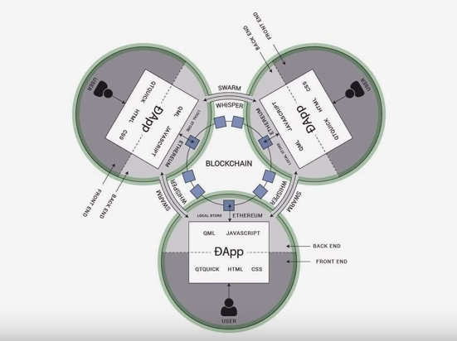

**FIG 6: ILLUSTRATION OF A DAPP THAT USES A BLOCKCHAIN WITH SMART CONTRACTS COMBINED WITH THE PILLARS OF SWARM AND WHISPER.**

**6 ETHEREUM INSTALLATION COMPONENTS**

**What Is Truffle Suite?**

Truffle Suite is a development environment based on Ethereum Blockchain, used to develop DApps (Distributed Applications). Truffle is a one-stop solution for building DApps: Compiling Contracts, Deploying Contracts, Injecting it into a web app, Creating front-end for DApps and Testing.

Truffle Suite has three components: 

**Truffle :** It is a Development Environment, Testing Framework and Asset pipeline for Ethereum Blokchains.

**Ganache :** Ganache is a personal Ethereum Blockchain used to test smart contracts where you can deploy contracts, develop applications, run tests and perform other tasks without any cost

**Drizzle :** Drizzle is a collection of libraries used to create easy and better front-end for Ethereum DApps

**Features Of Truffle Ethereum:-**

Here’s a list of features that makes Truffle a powerful tool to build [Ethereum](https://www.edureka.co/blog/what-is-ethereum/) based DApps: 

* Built-in support to Compile, Deploy and Link smart contracts
* Automated Contract testing
* Supports Console apps as well as Web apps
* Network Management and Package Management
* Truffle console to directly communicate with smart contracts
* Supports tight integration

**What Is MetaMask?**

MetaMask is an easy-to-use browser plugin (for Google-Chrome, Firefox and Brave browser), that provides a graphical user interface to make Ethereum transactions. It allows you to run Ethereum DApps on your browser without running a full Ethereum node on your system. Basically, MetaMask acts as a bridge between Ethereum Blockchain and the browser. MetaMask is open-source and provides the following exciting features:

* You can change the code of MetaMask to make it what you want it to be
* Provides built-in coin purchasing
* Local-key Storage

**7 IMPLEMENTATION AND RESULTS**

* **Supplier :**

1. Add Car Parts:

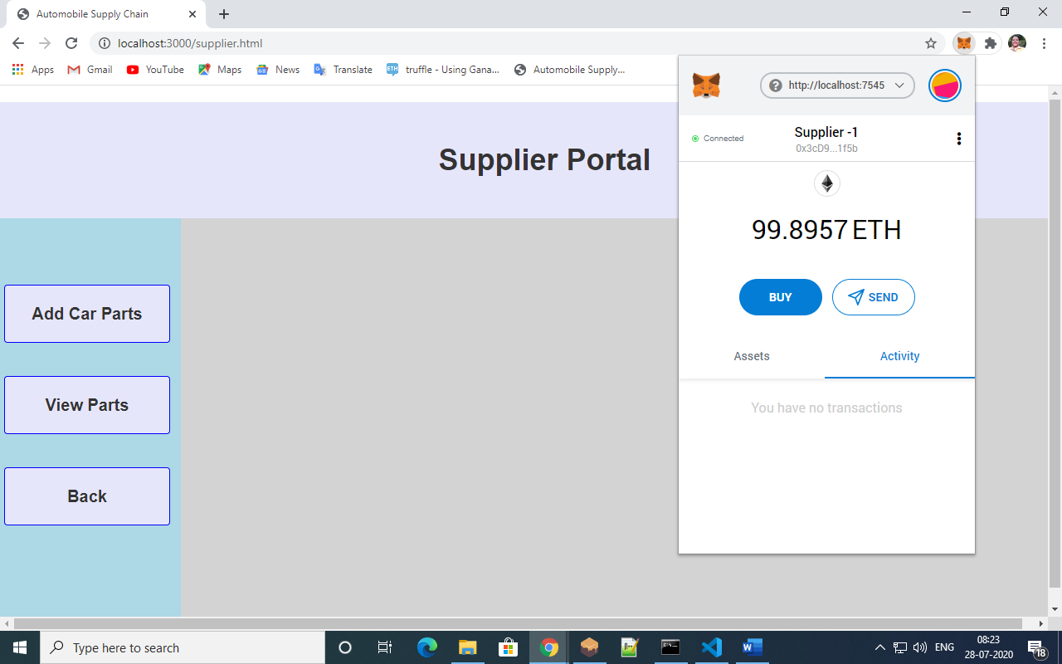

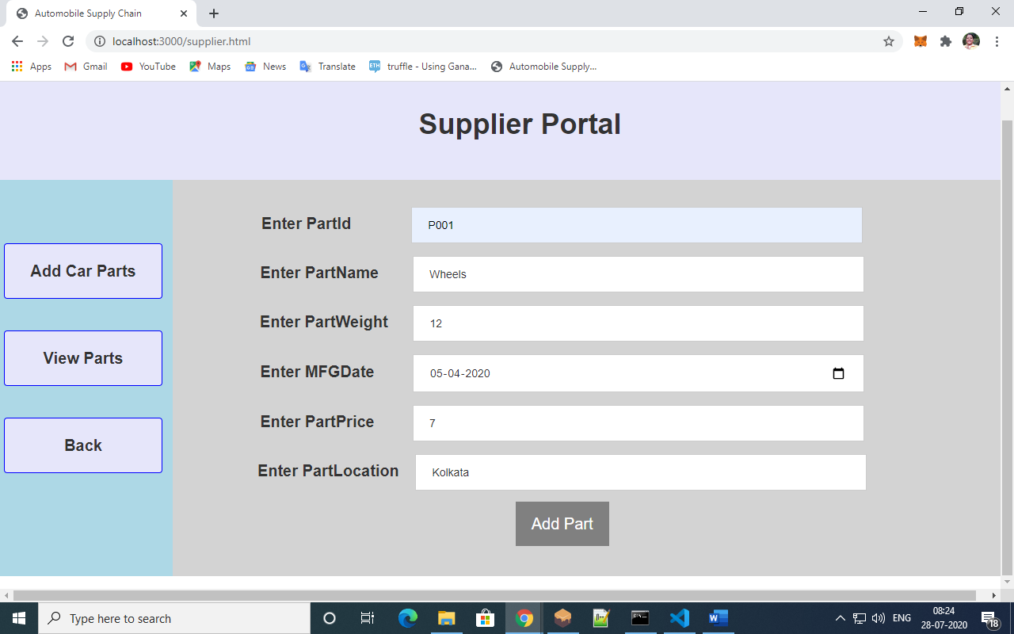

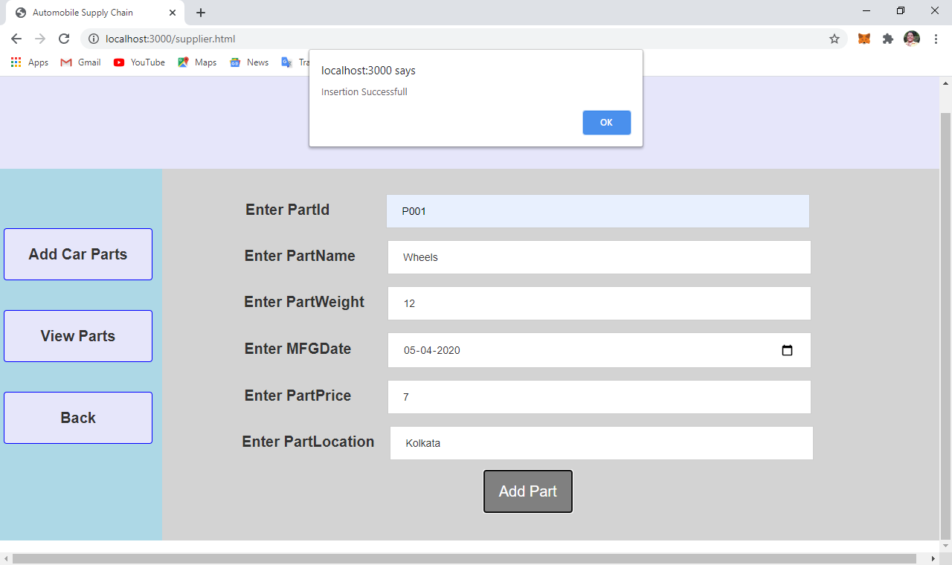

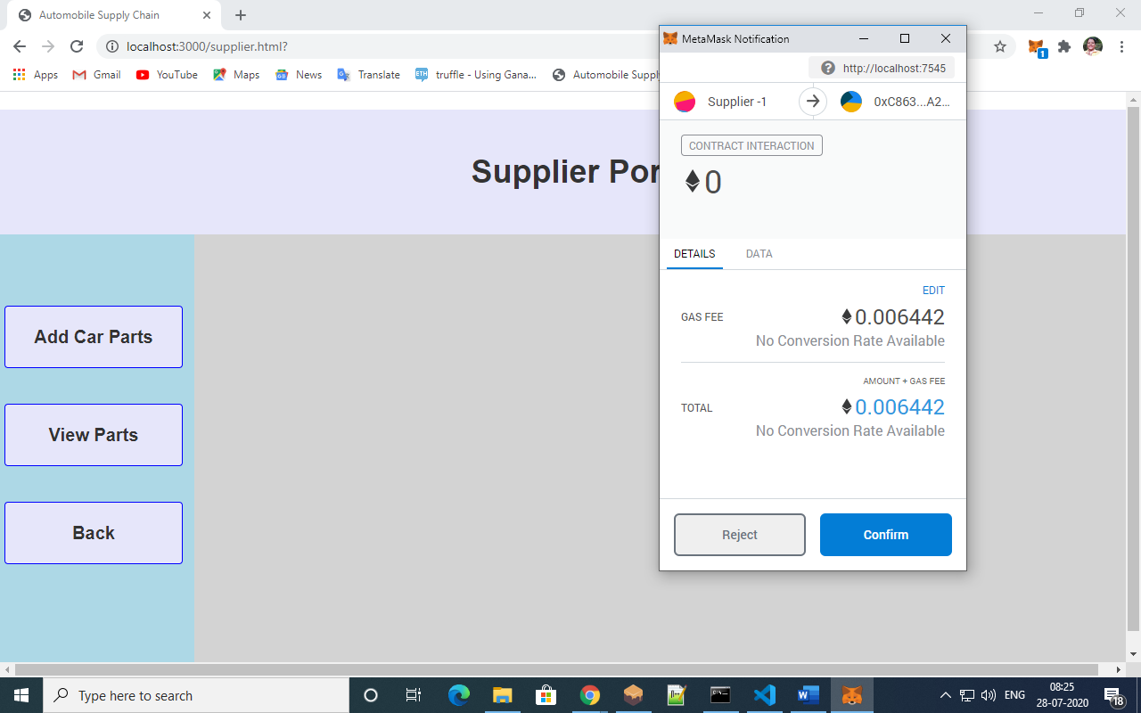

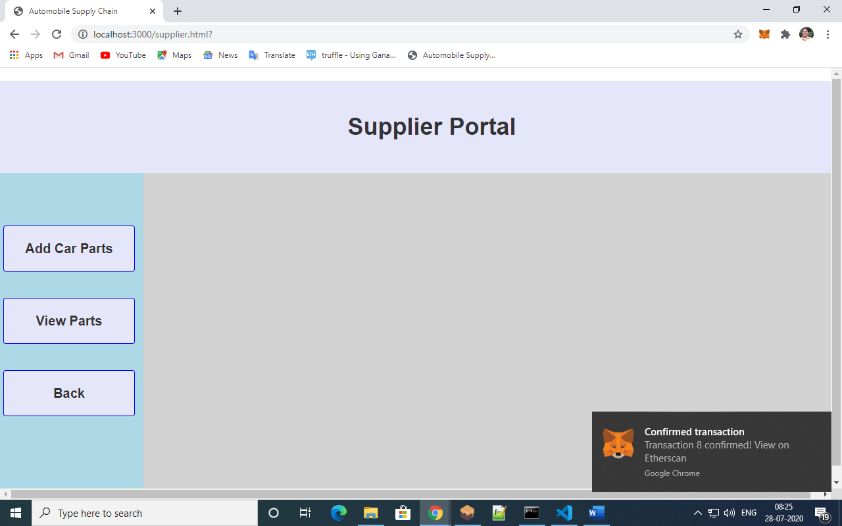

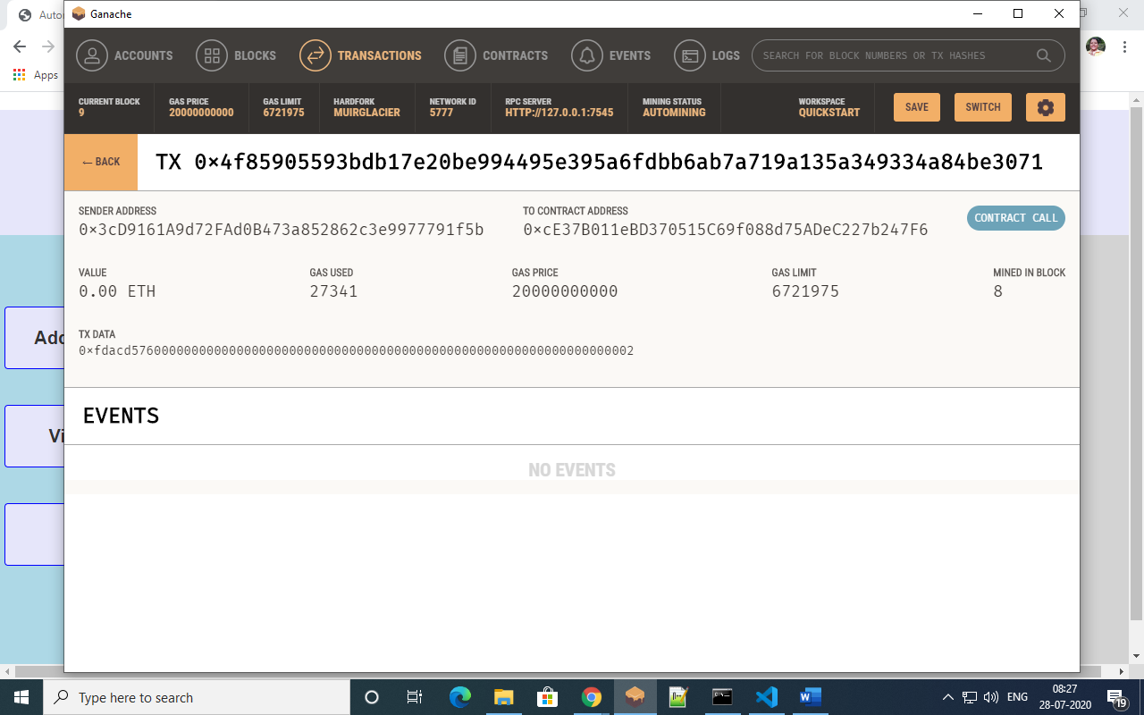

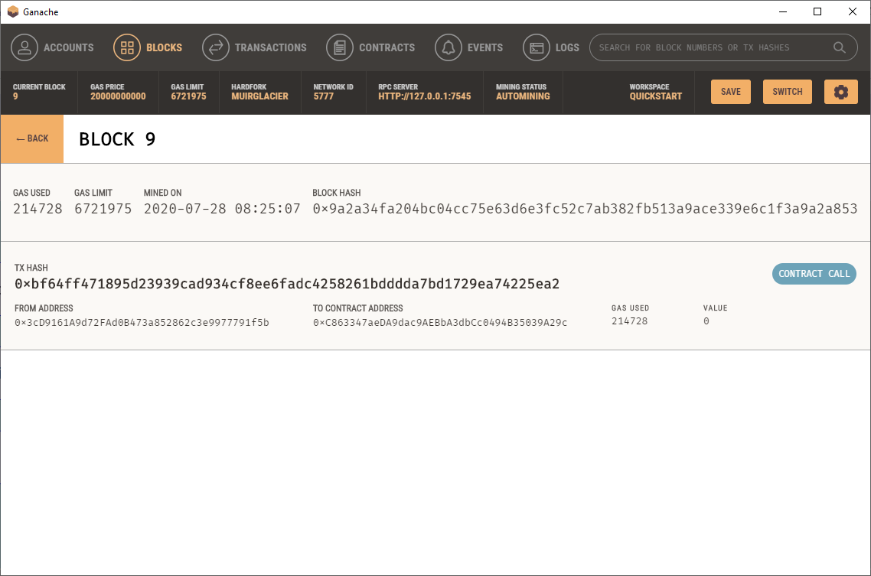

1. View Parts:

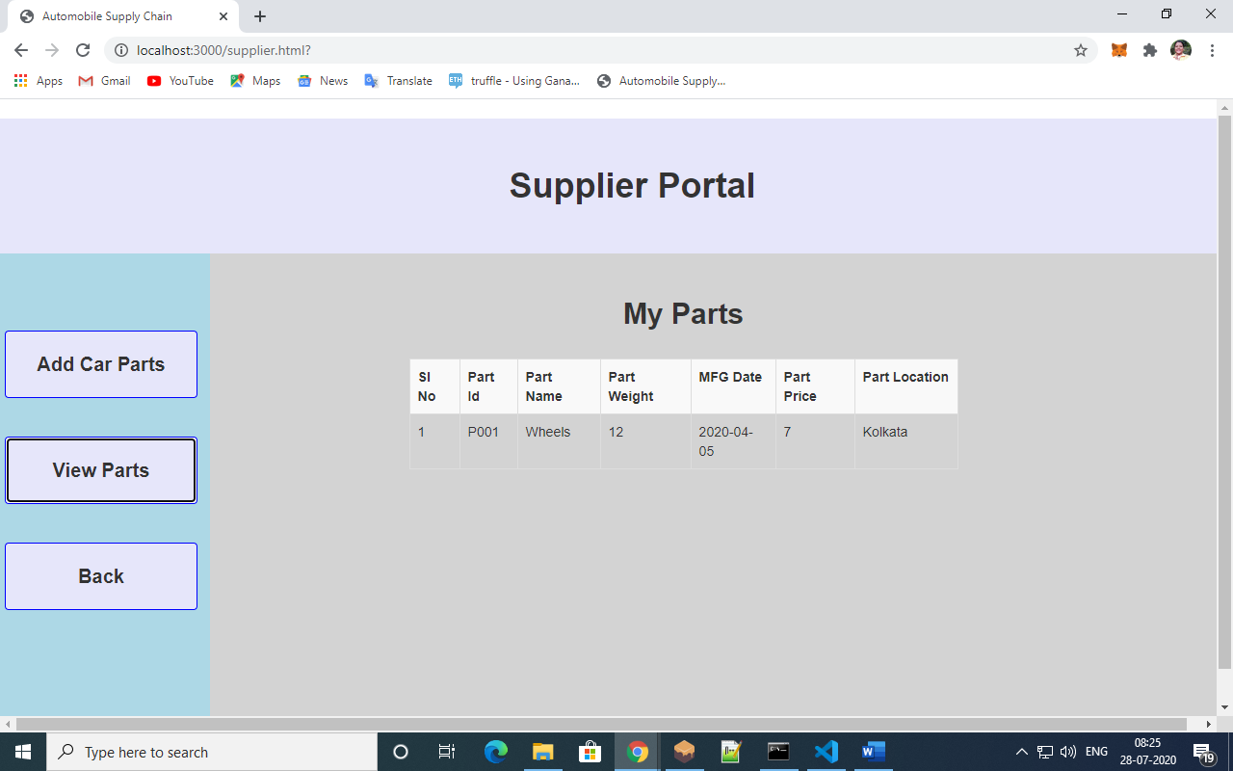

* **Manufacturer :**

1. Buy Car parts:

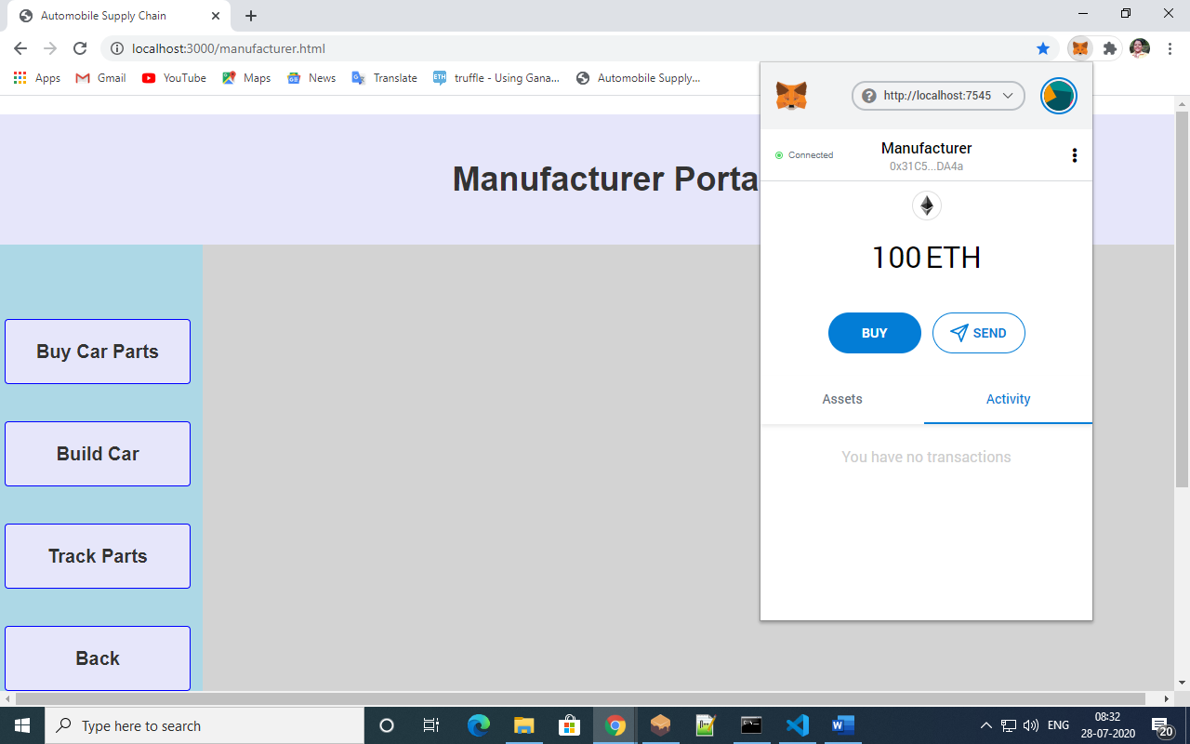

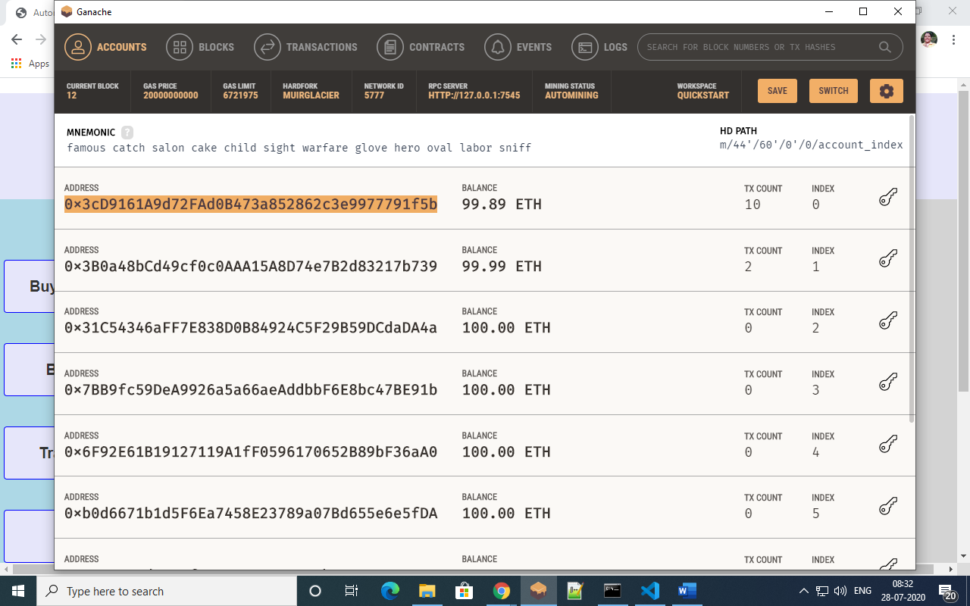

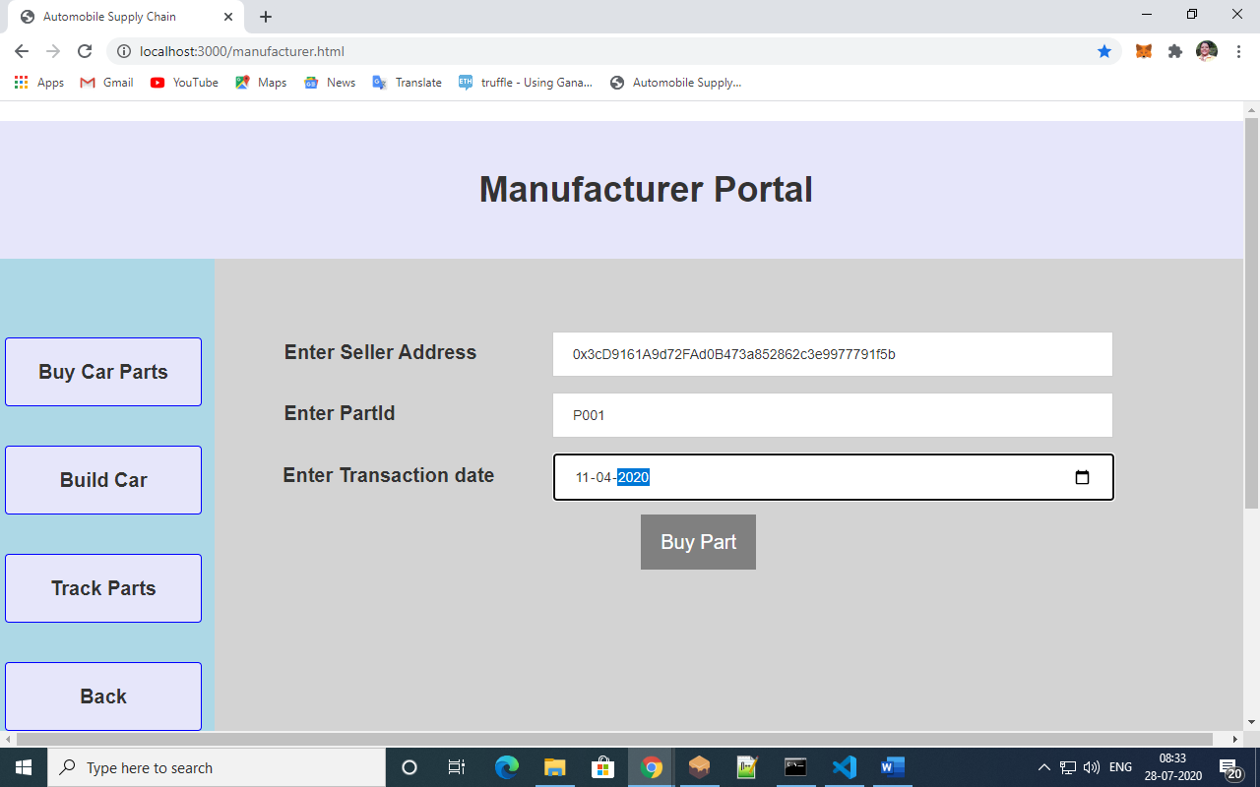

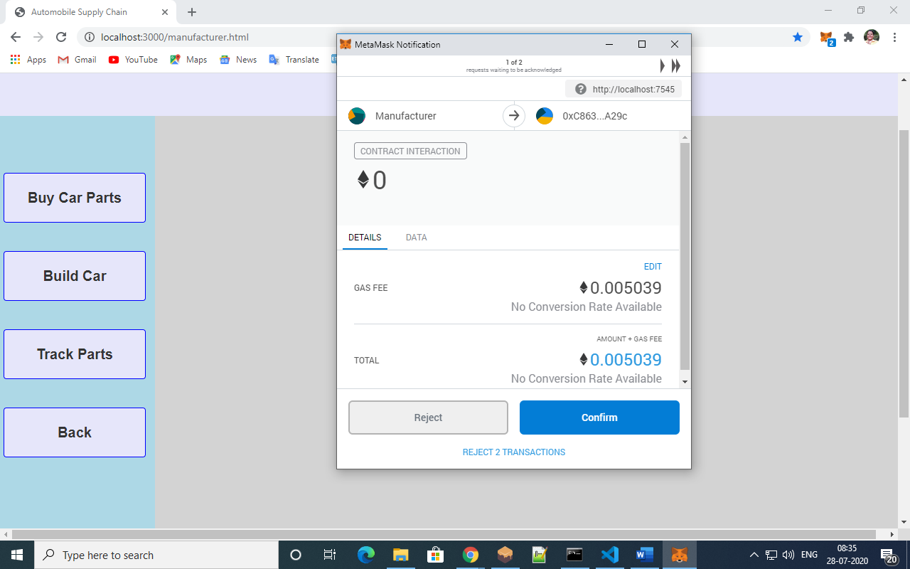

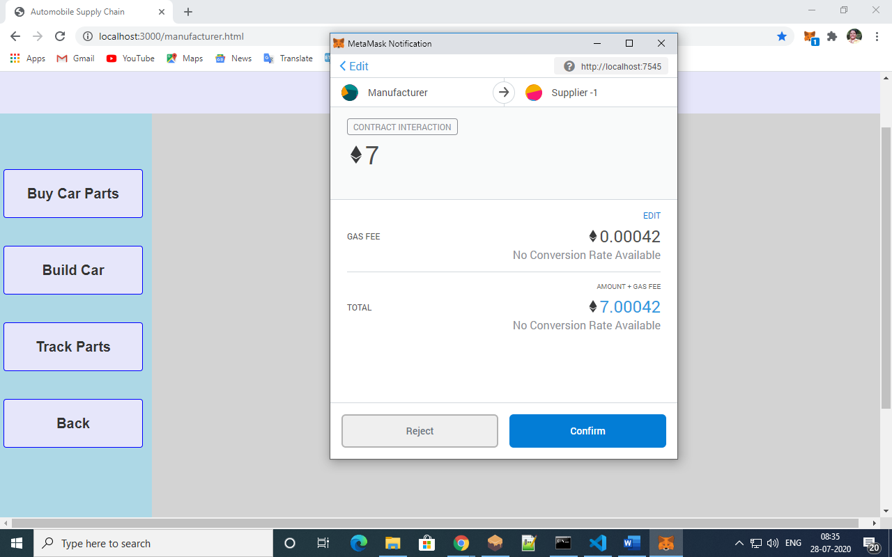

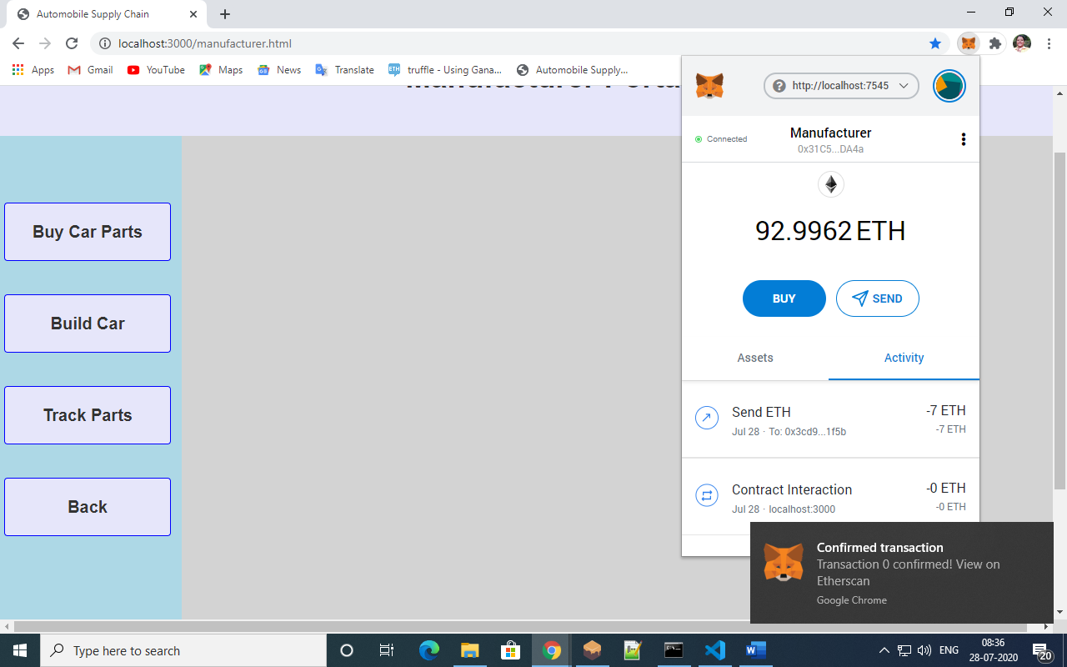

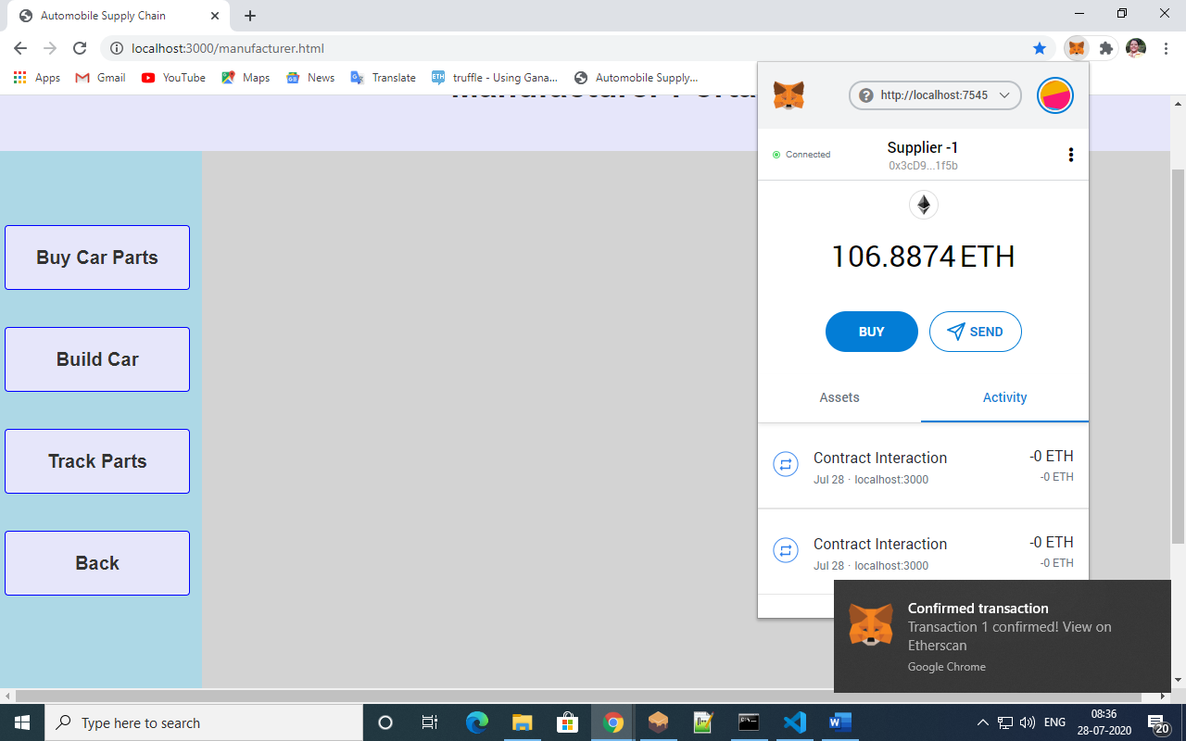

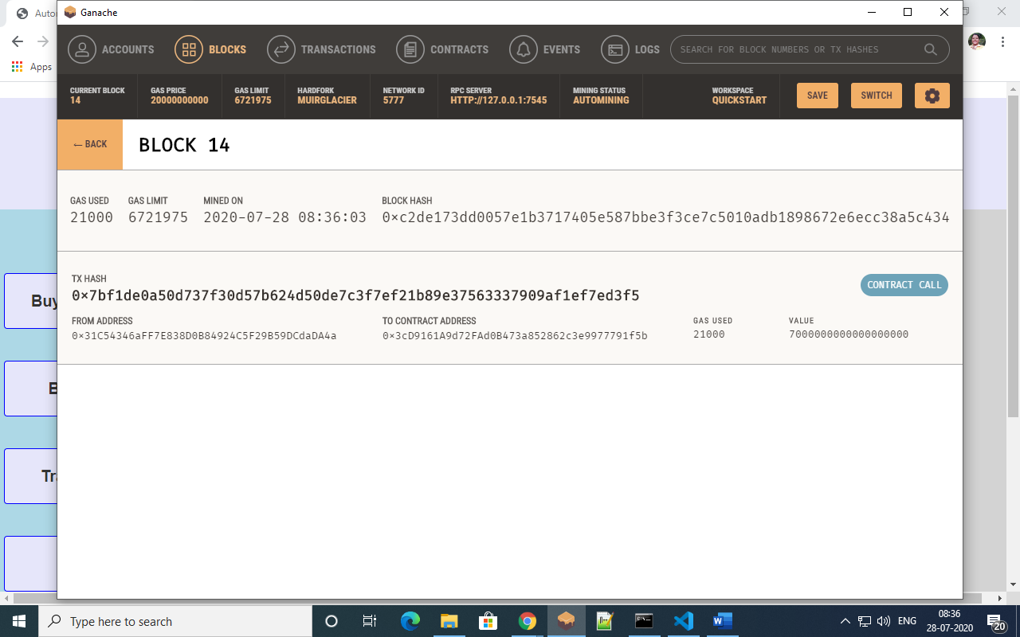

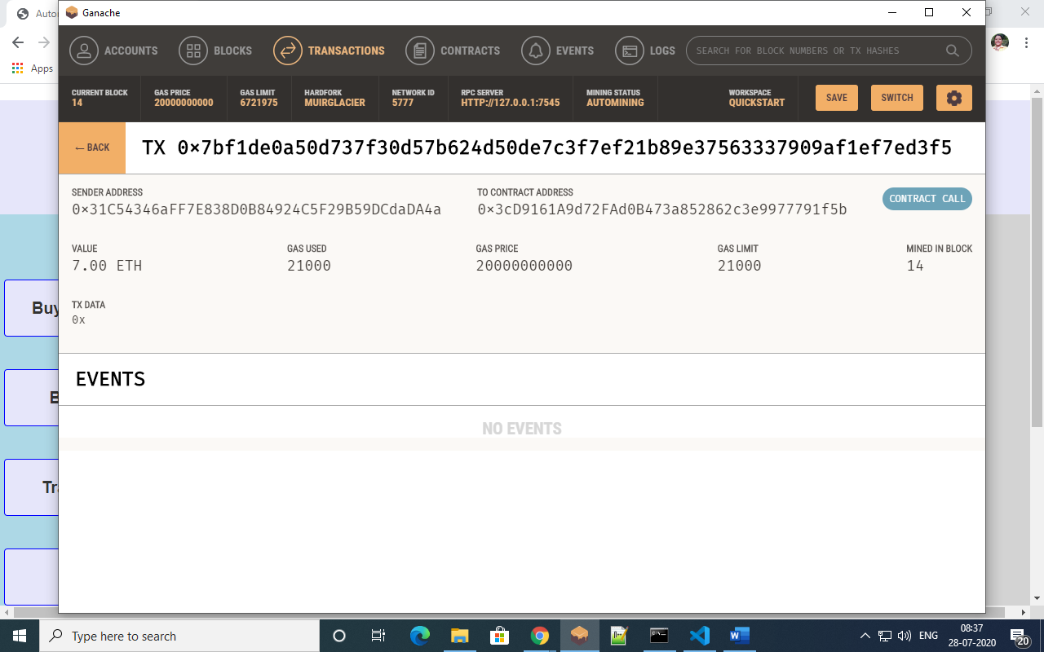

1. Build Car:

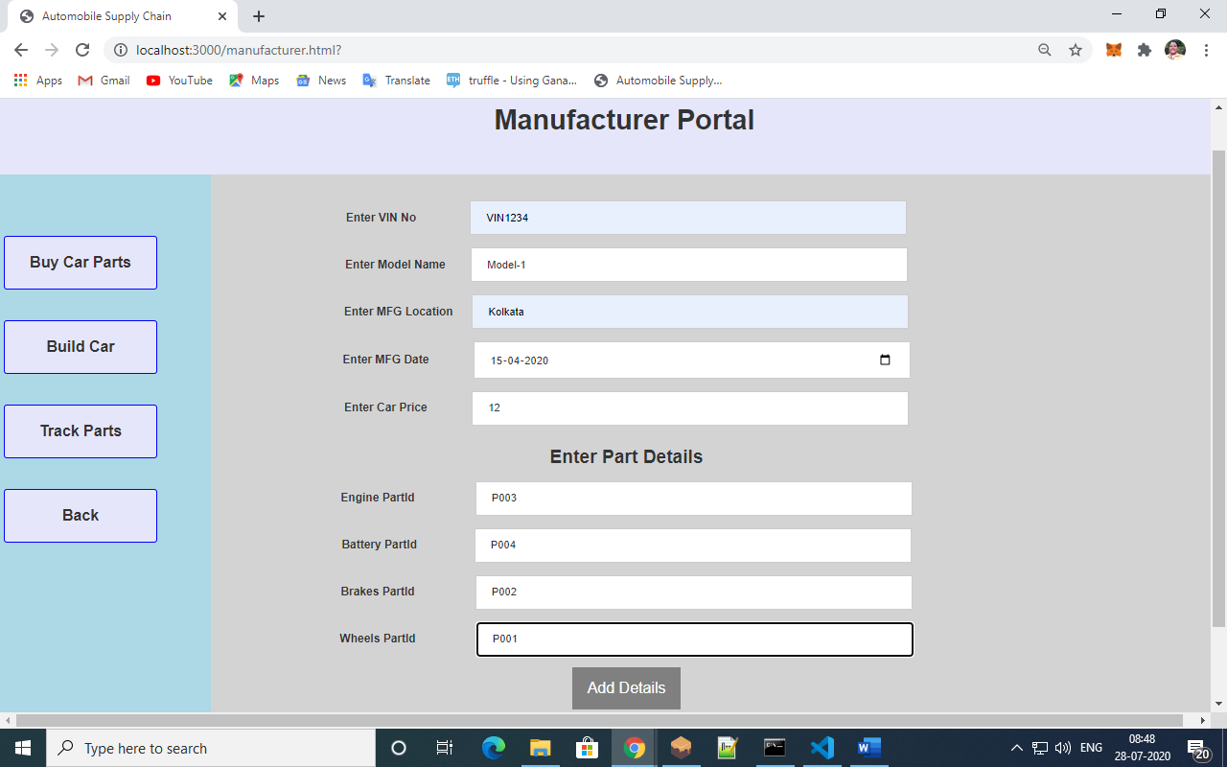

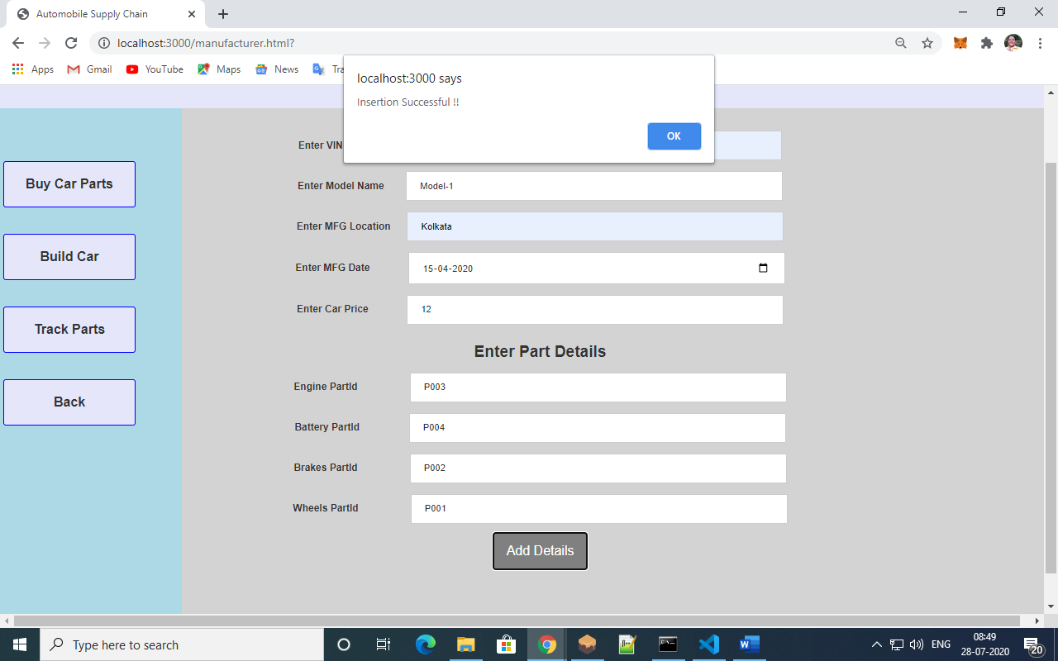

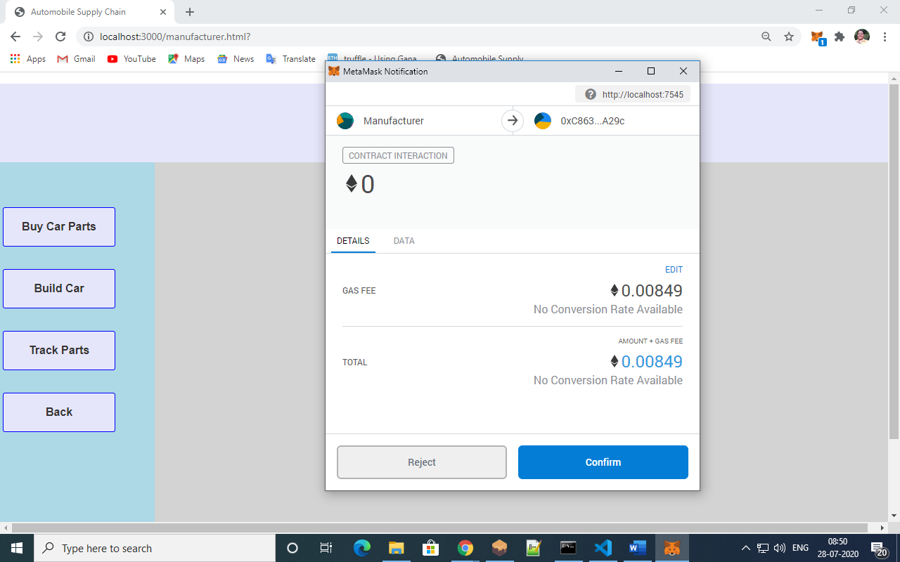

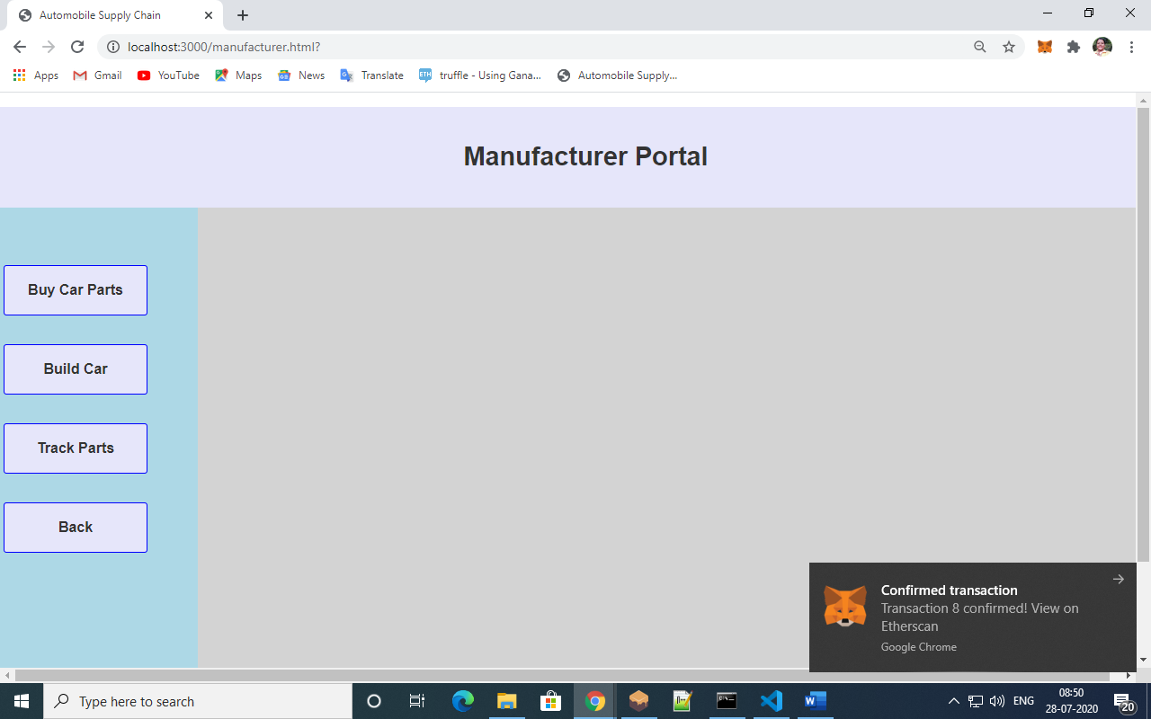

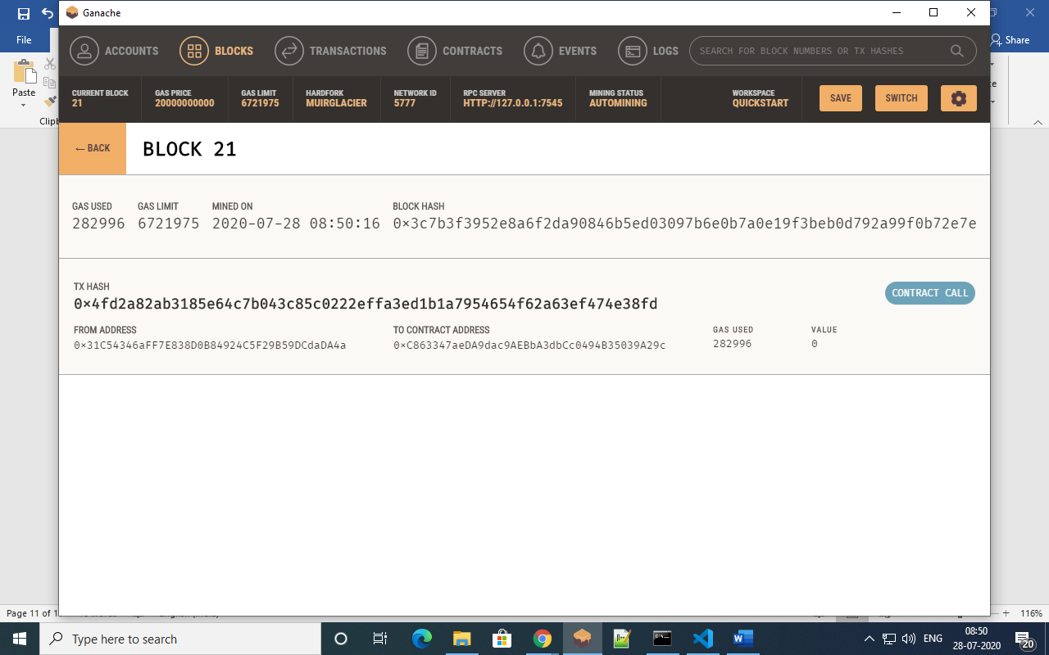

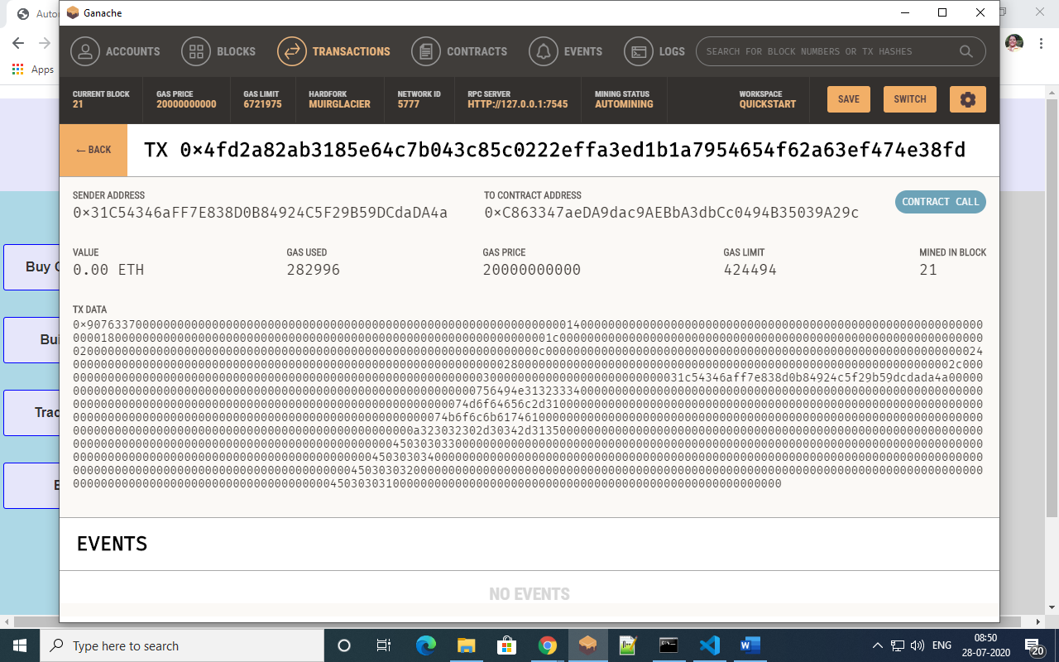

1. Track Parts:

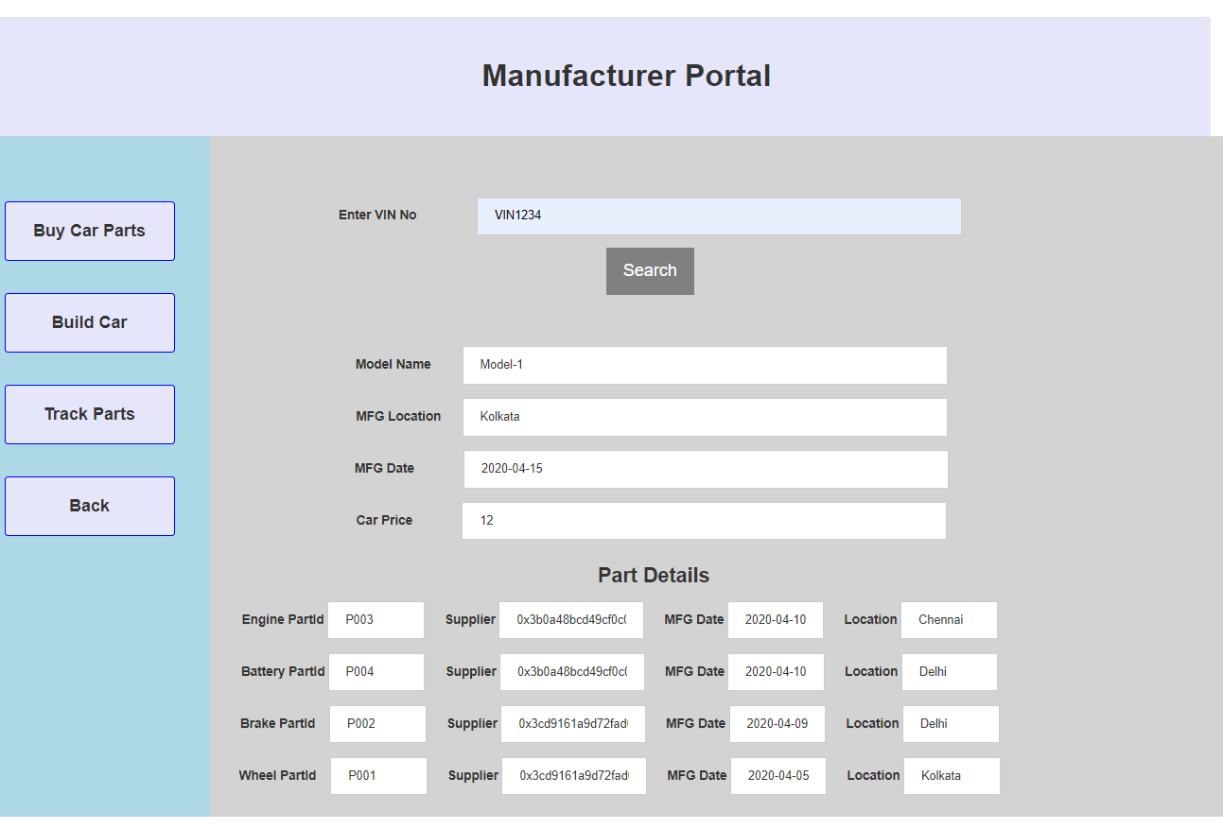

* **Dealer :**

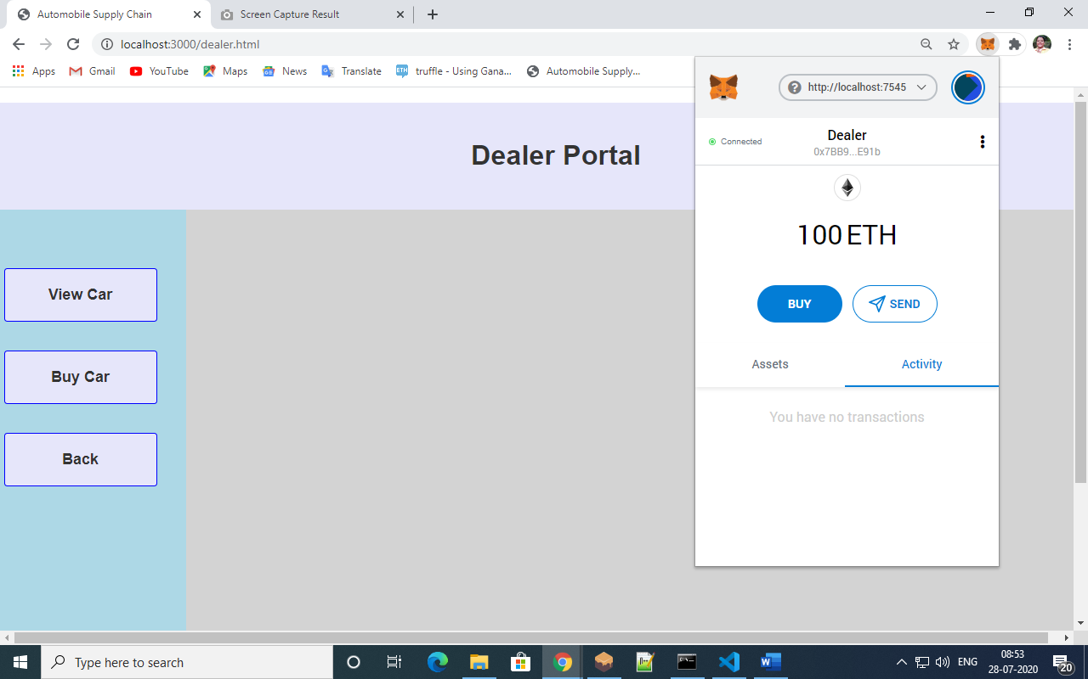

1. View Car : (Search using manufacturer address)

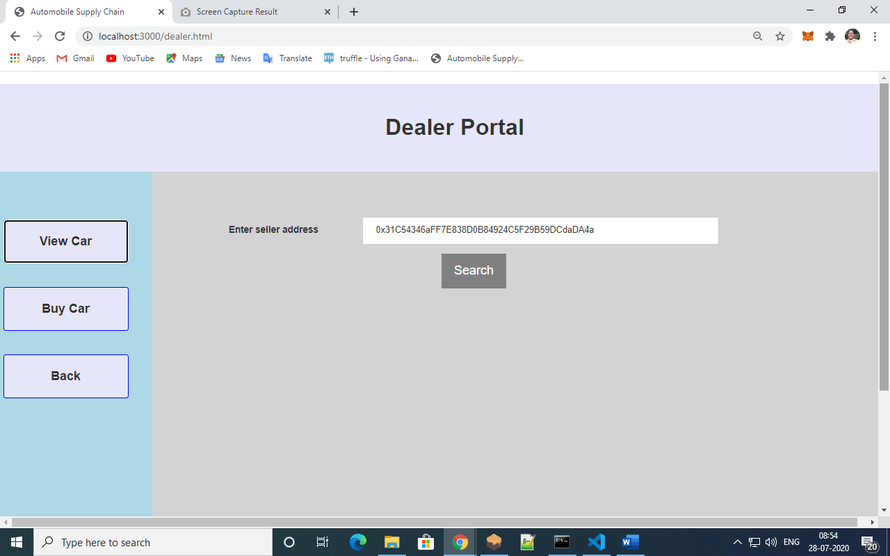

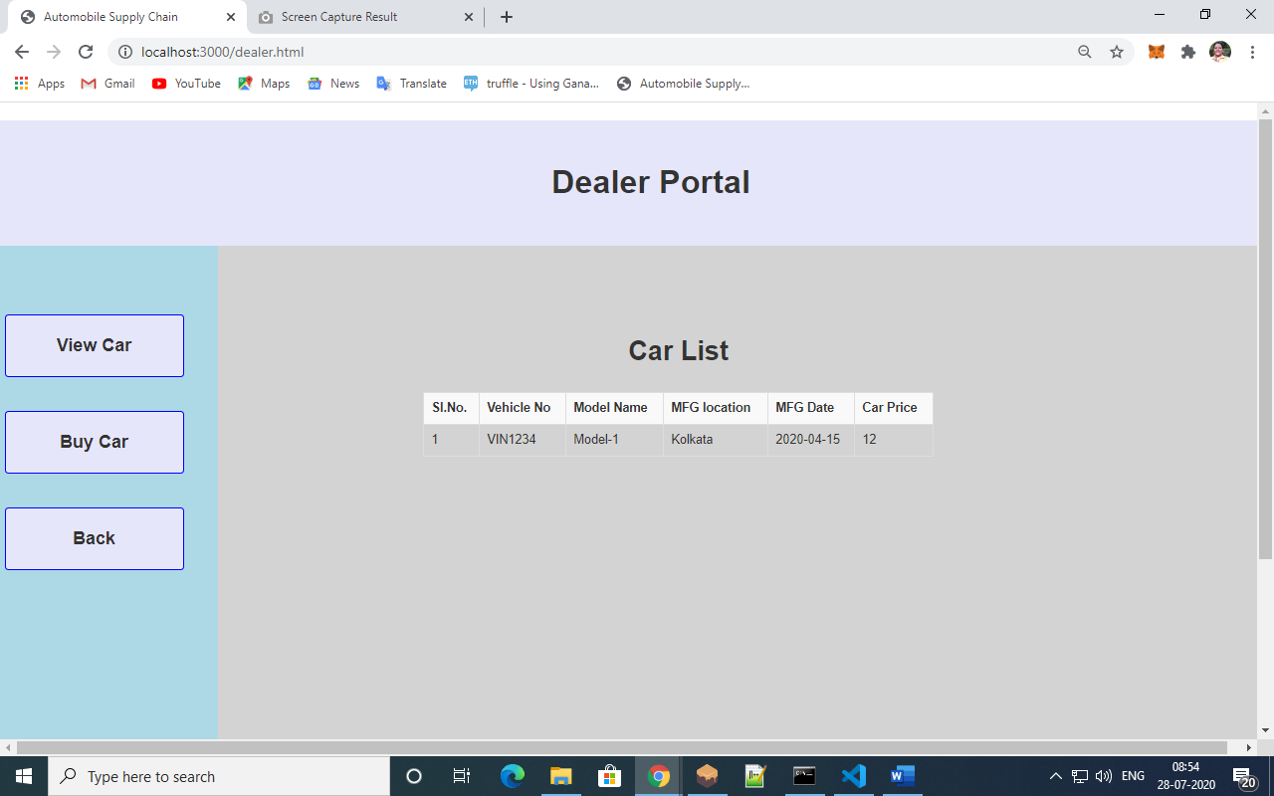

1. Buy Car:

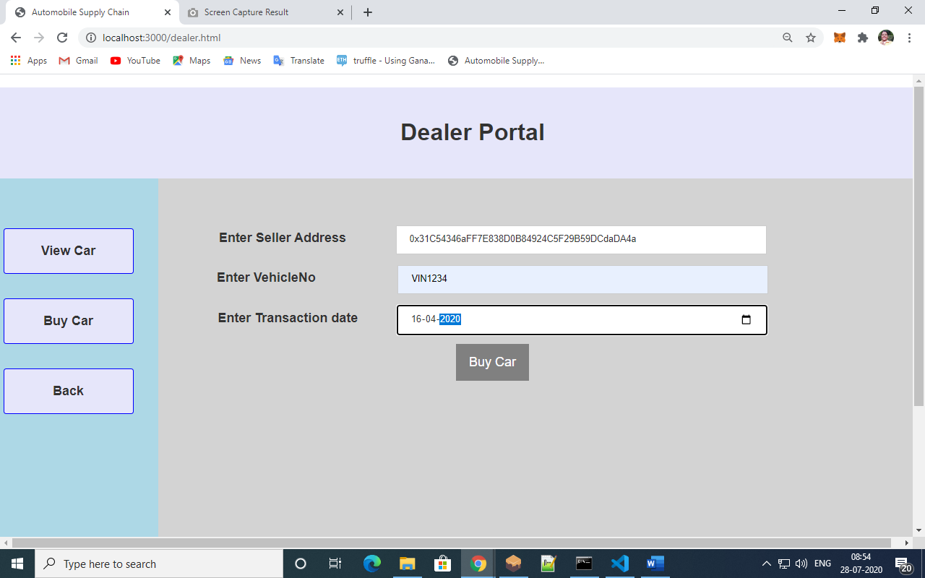

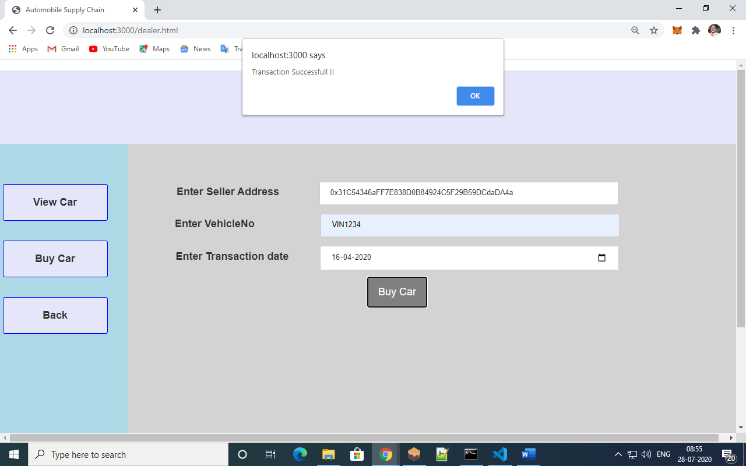

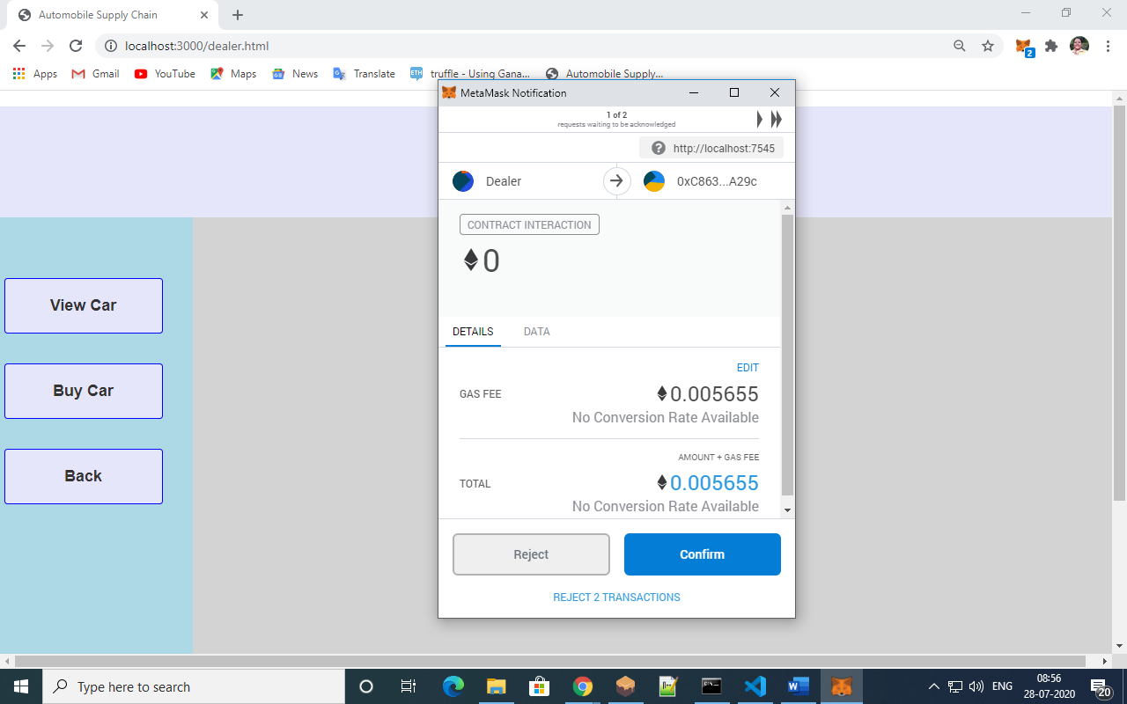

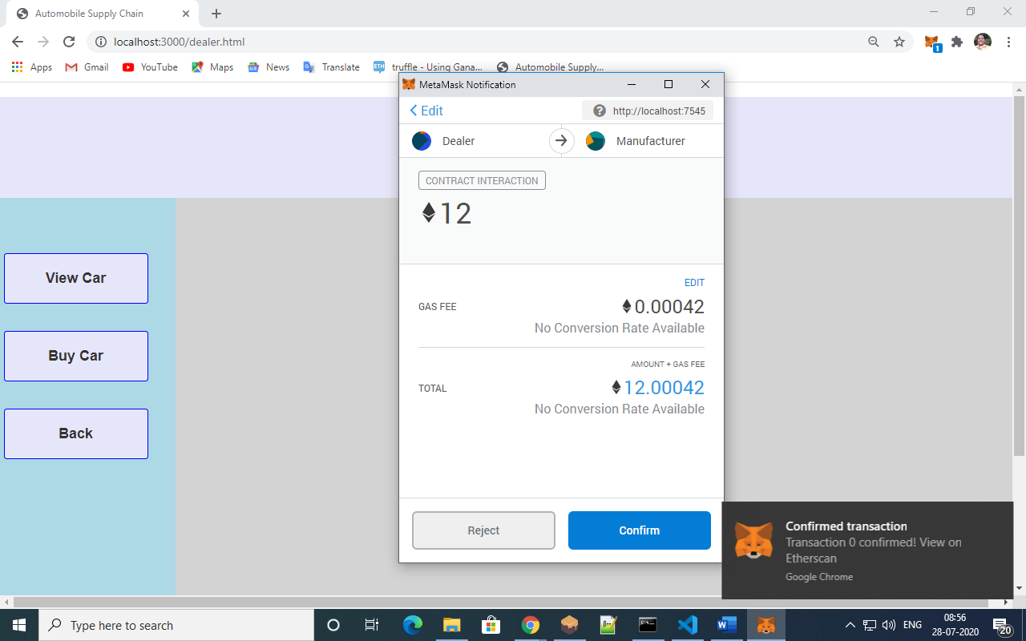

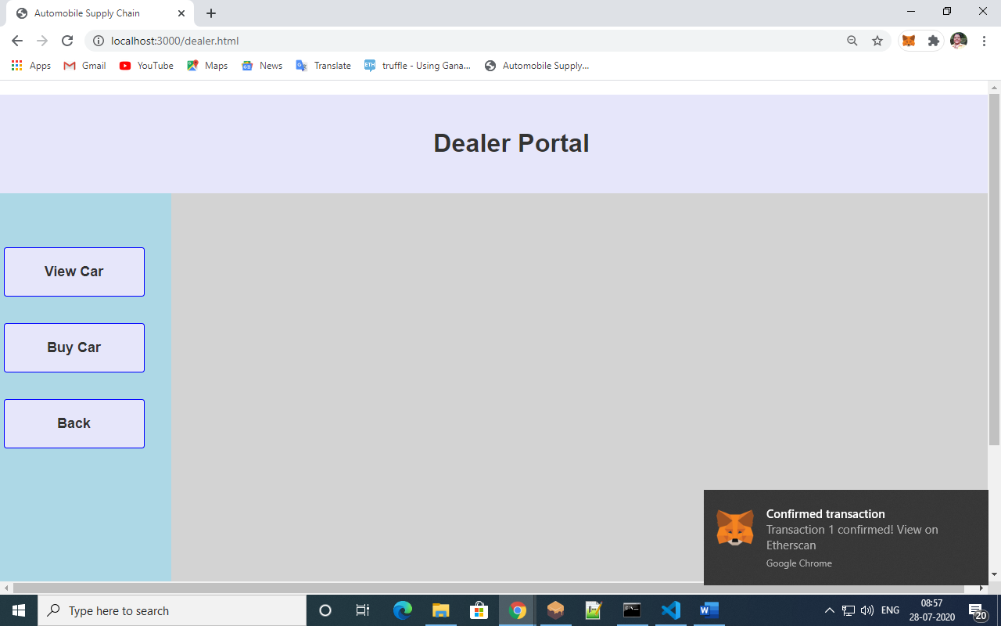

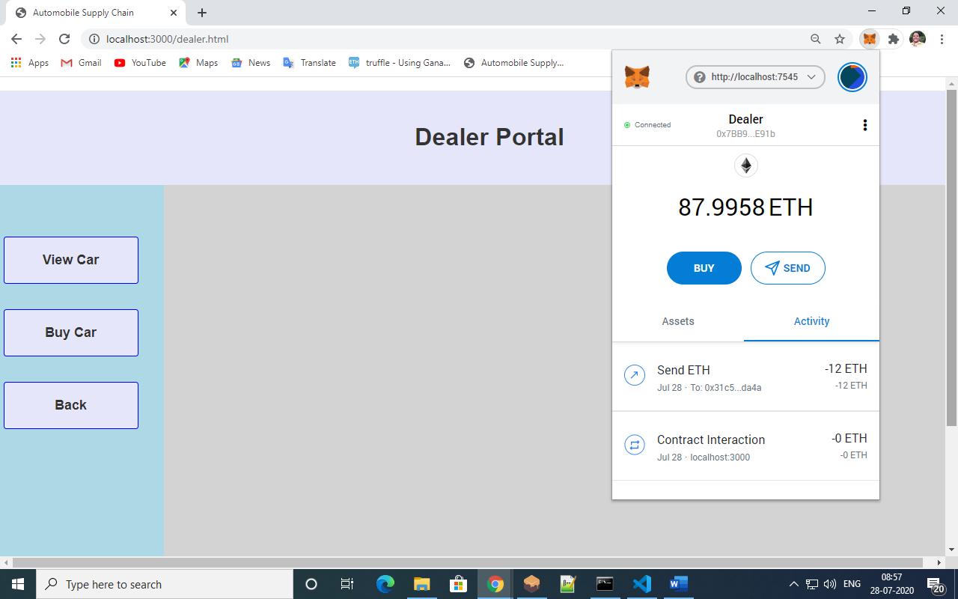

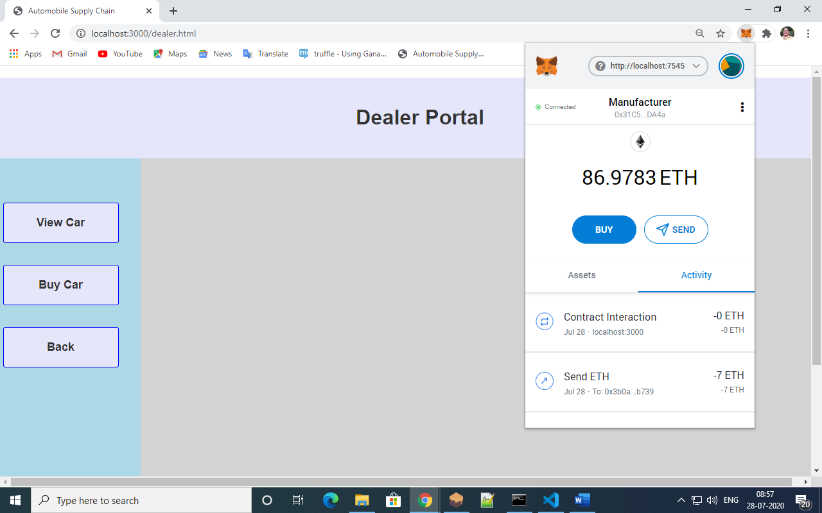

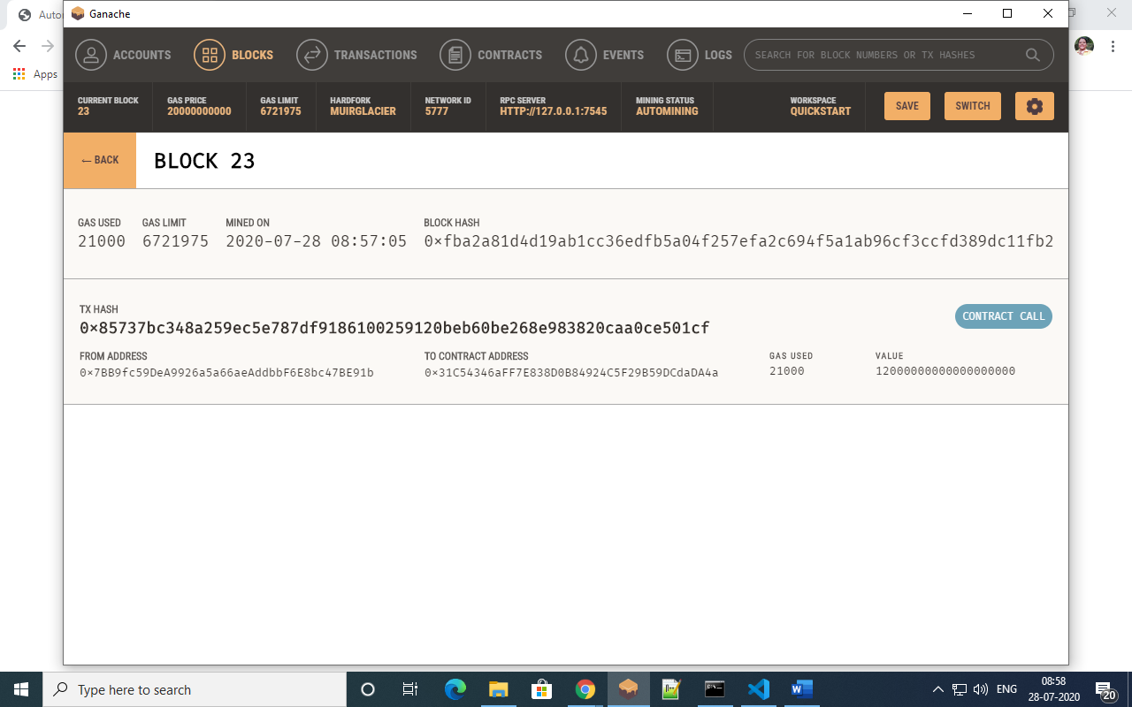

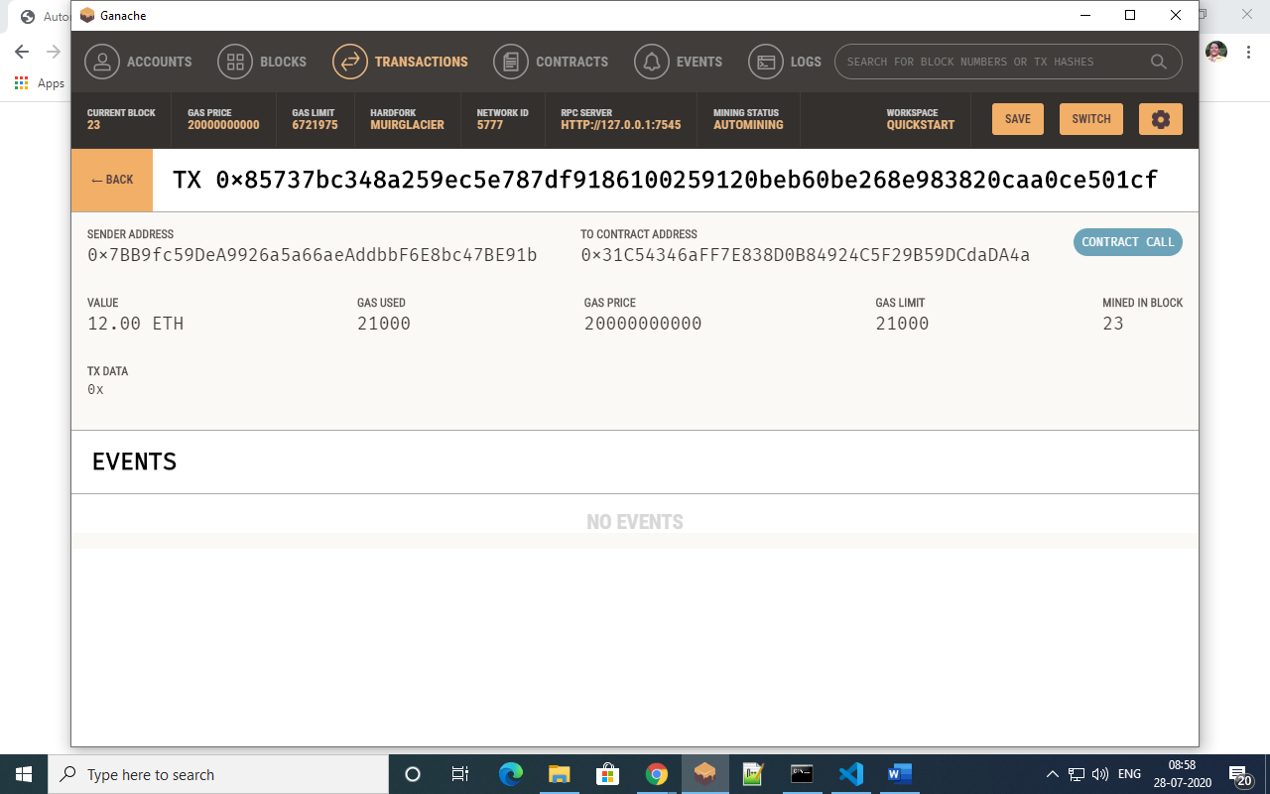

* **Customer:**

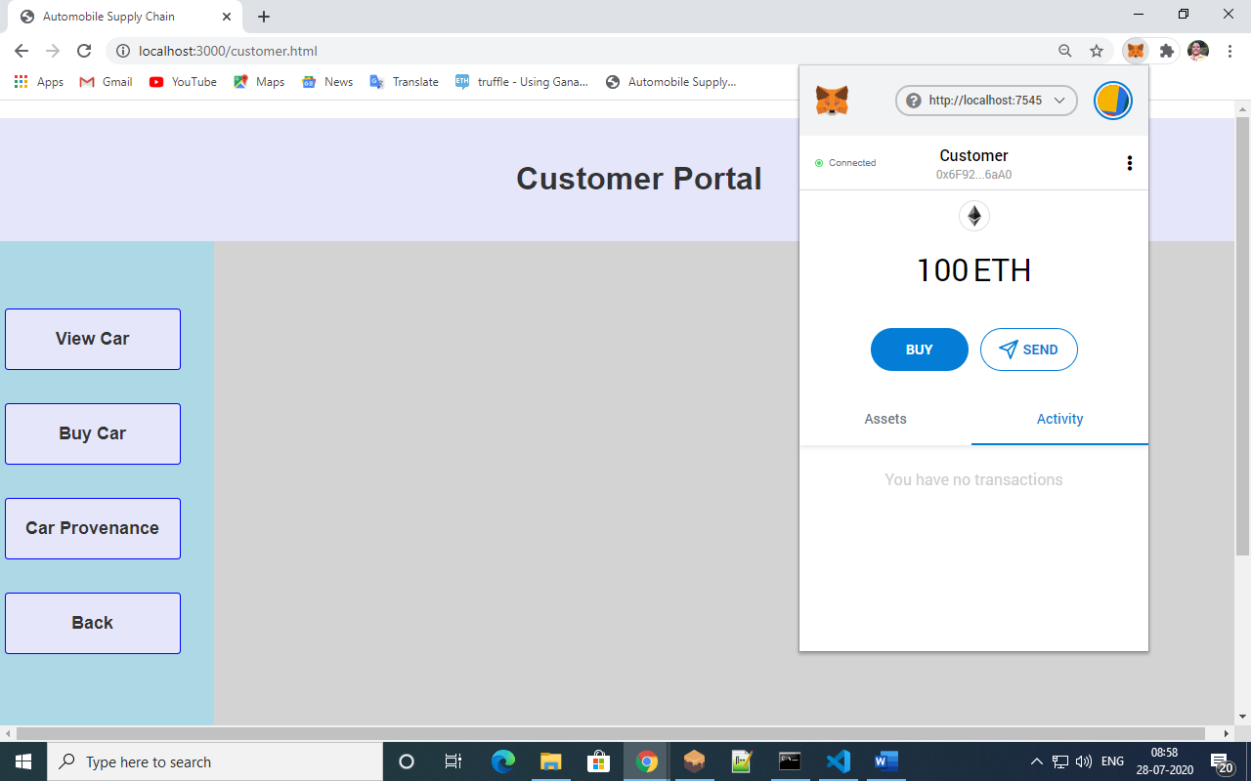

1. View Car: (search using Dealer address)

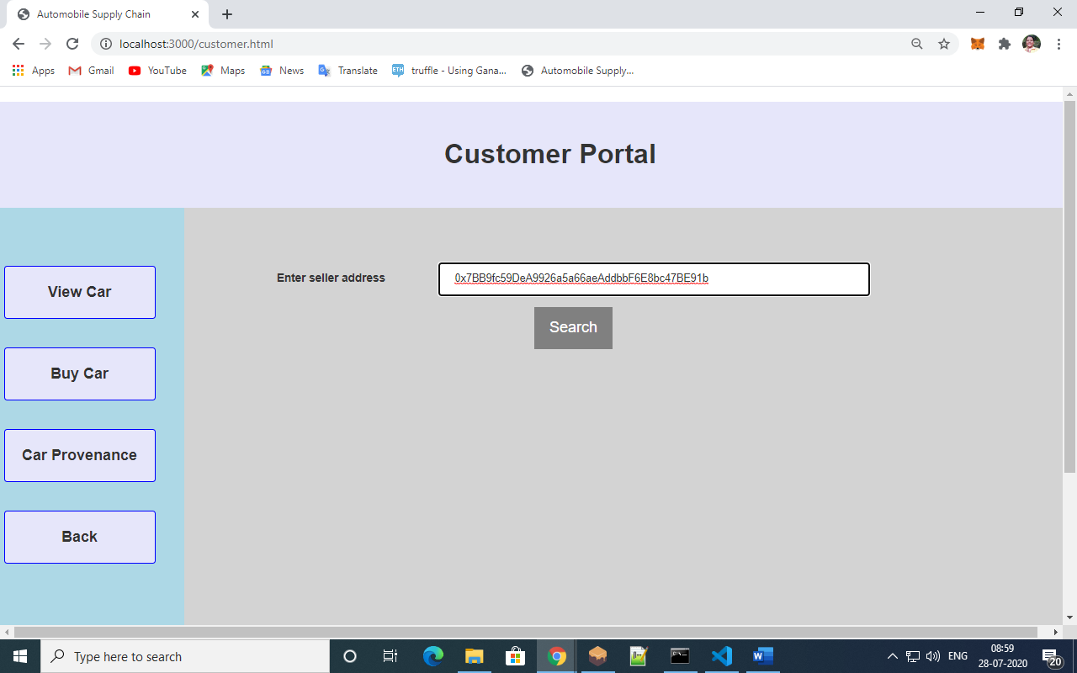

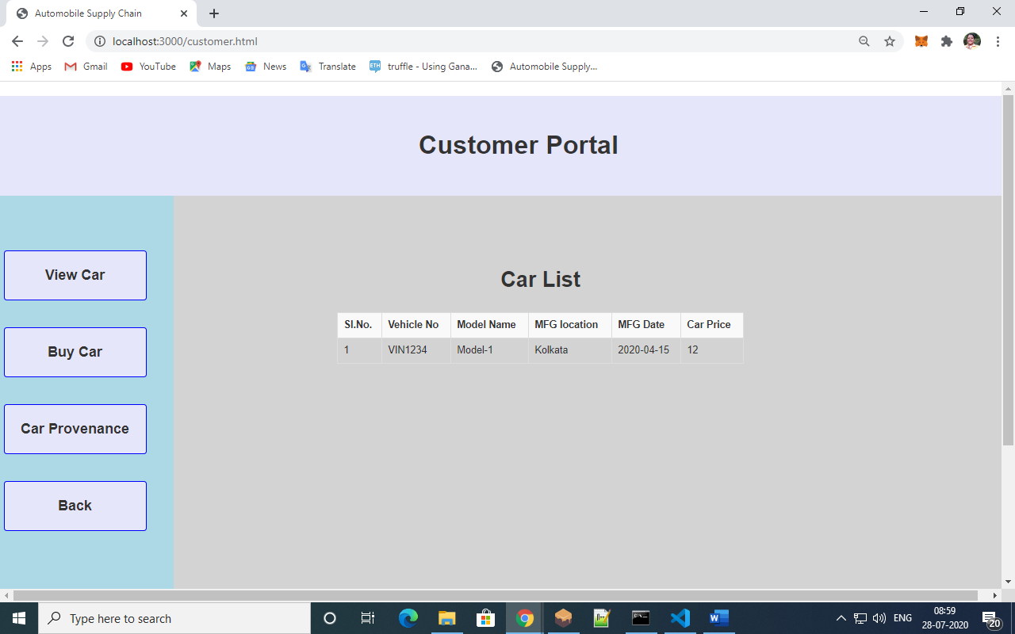

1. Buy Car:

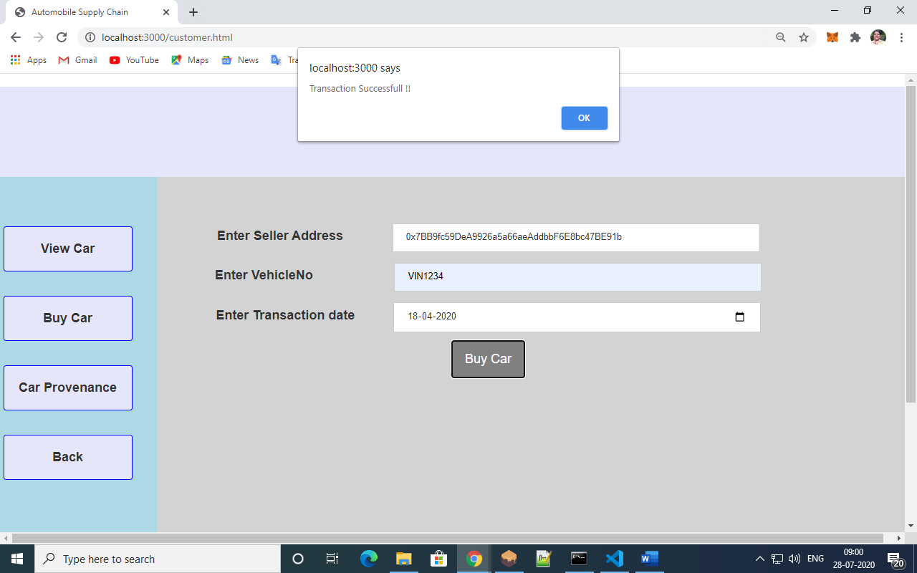

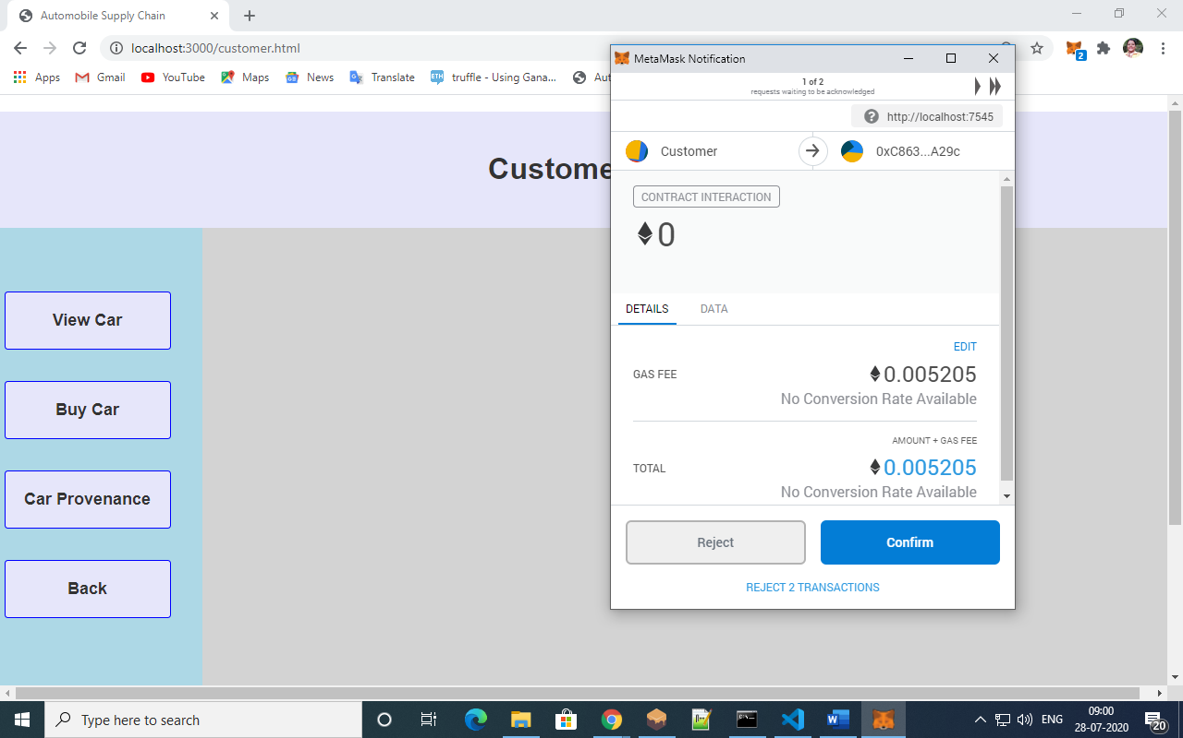

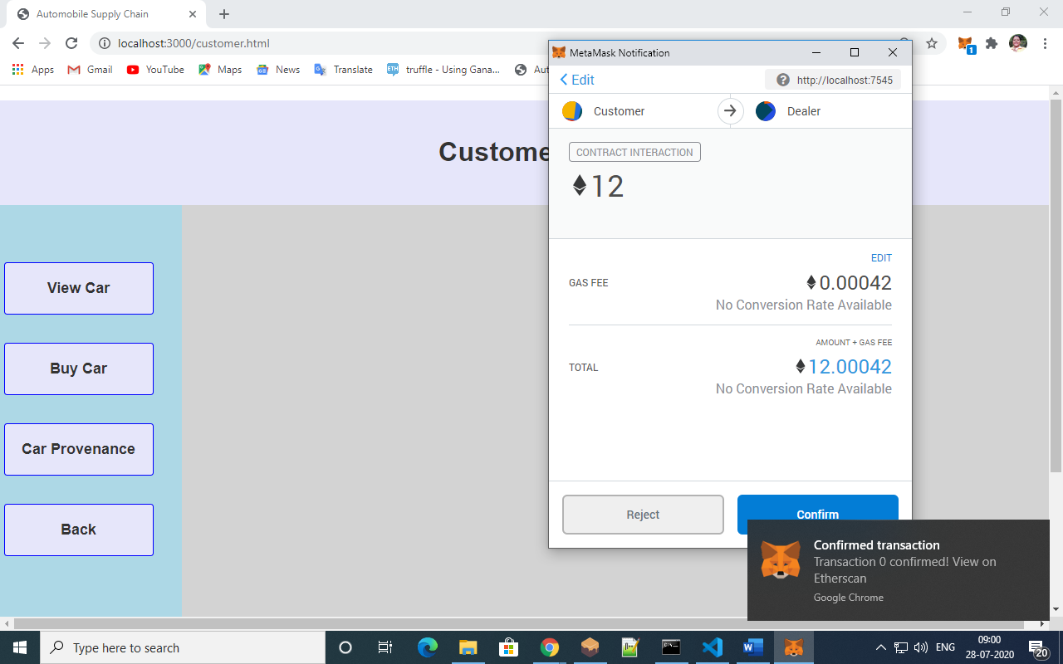

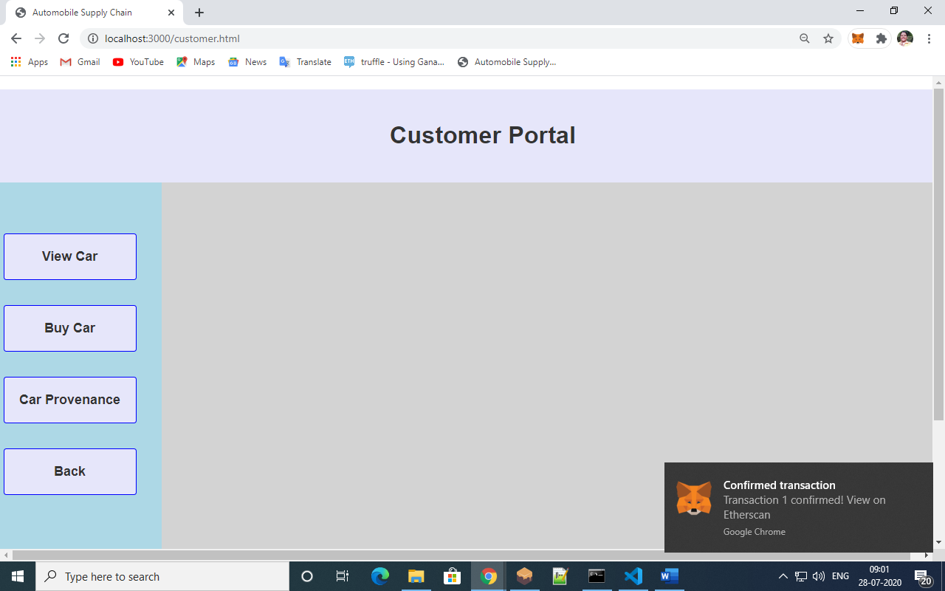

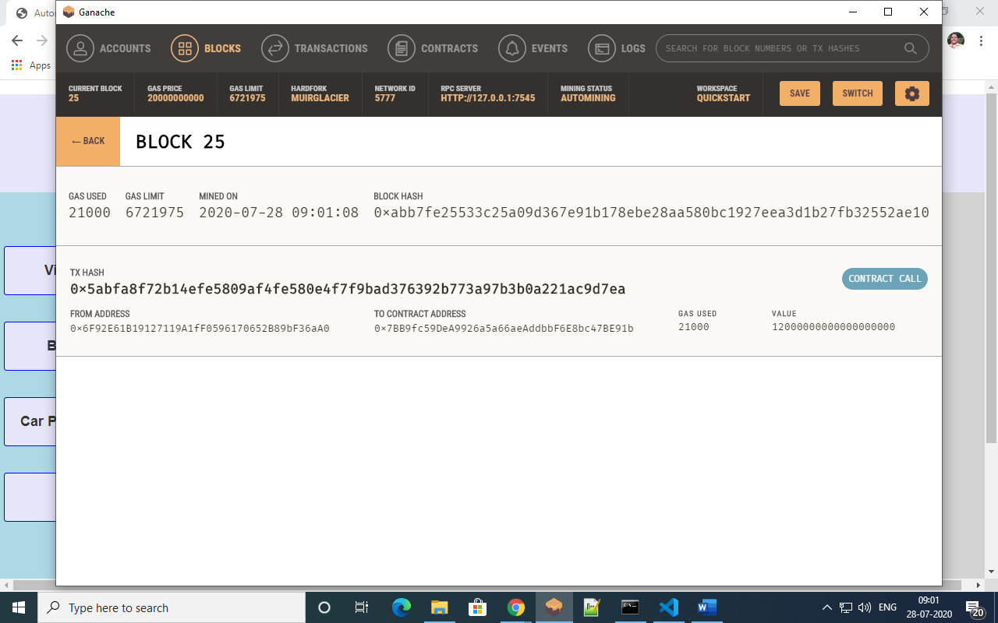

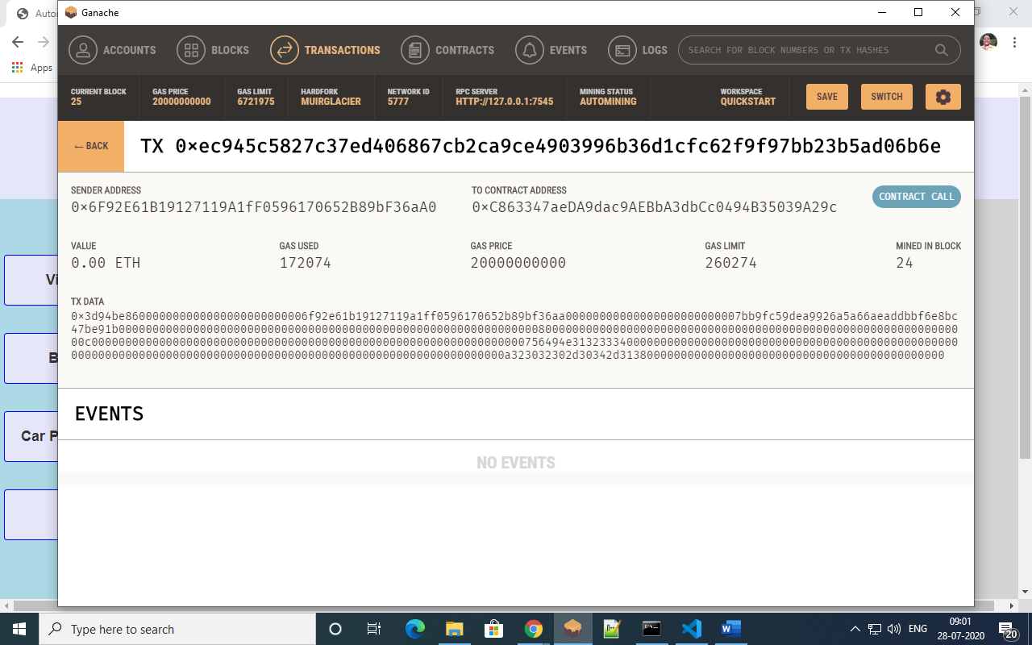

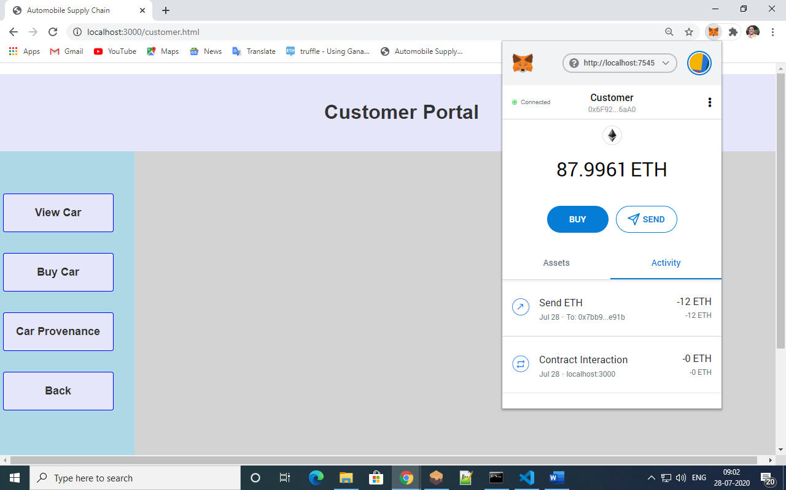

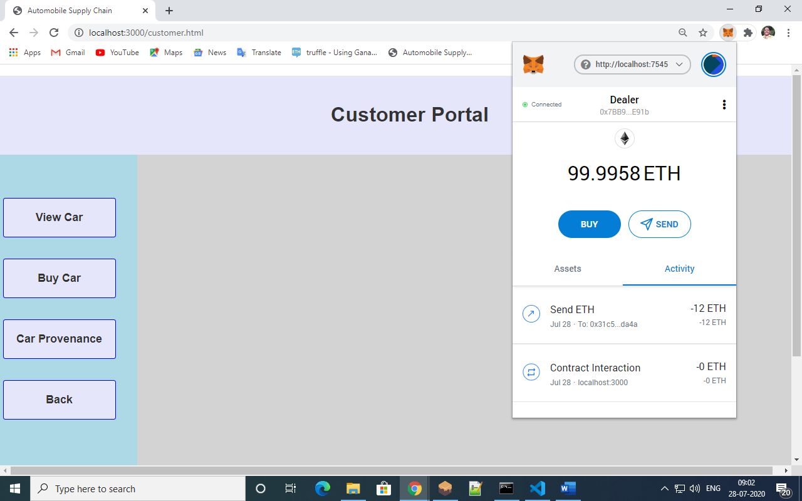

1. Car Provenance:

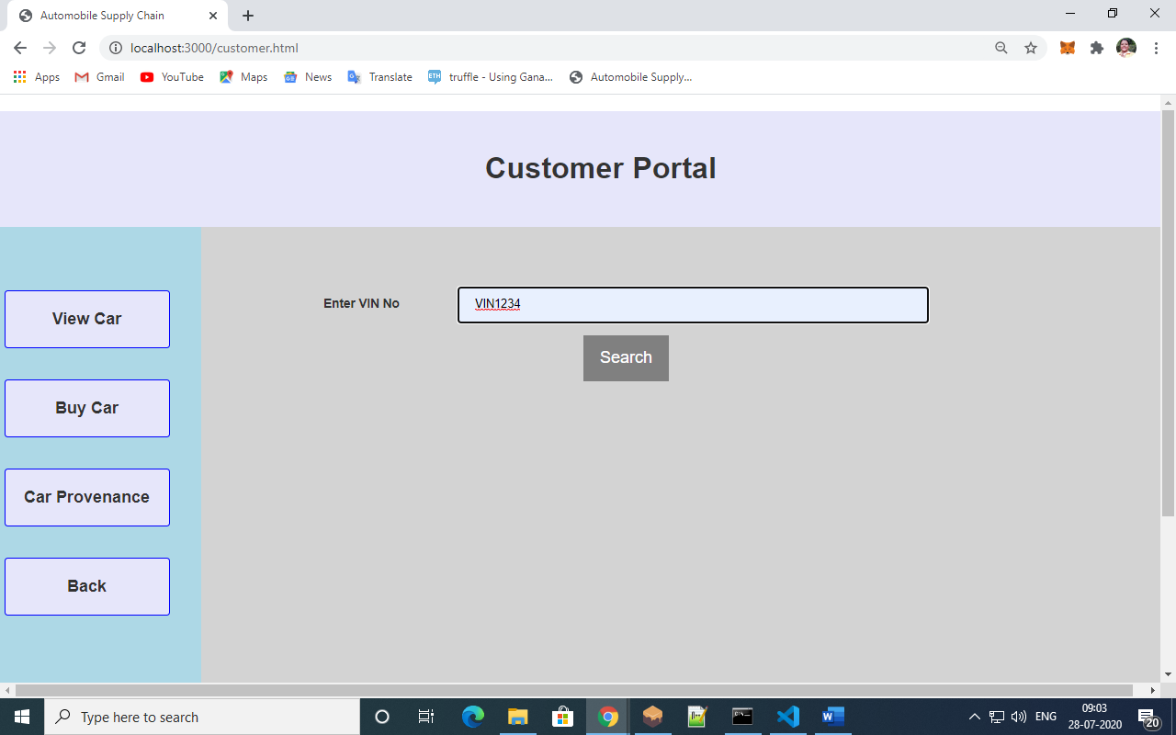

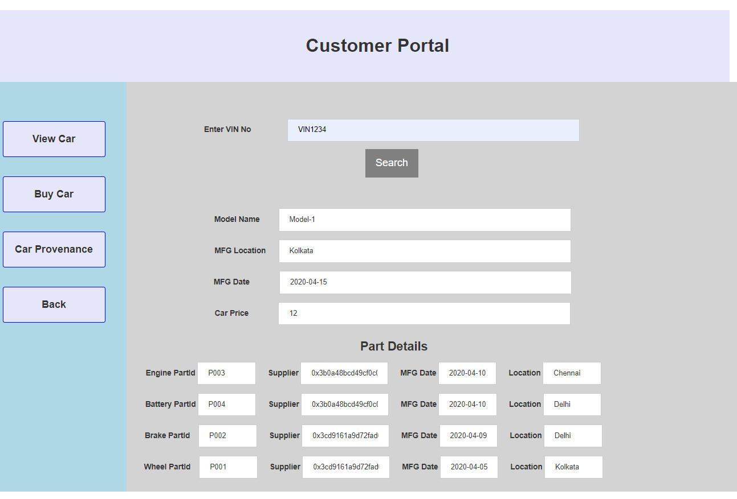

**8 CONSTRAINTS**

1. As the system is based on decentralization, therefore all the stakeholders need to be connected to the blockchain local network i.e. ganache.
2. There is no need for login and signup, the stakeholders can use their address to send ethers from one account to another account from metalmark.
3. The blocks created during each transaction are immutable in nature, therefore we cannot update or modify once a transaction has been recorded. Updating of blocks will lead to a broken blockchain .
4. After switching off the computer the records are lost as there is no facility in the blockchain network to store the data in the backend, when again we switch on the computer the ganache gives new addresses to create accounts. Therefore, in Ethereum decentralized applications there is no facility of storing records or data after we switch off our computers.
5. All the transactions are done between accounts addresses. Therefore, the stakeholders should have all the necessary Ethereum installation components installed in their computers.
6. Also, when an account is buying a car or its parts from another account, the price of the car or parts should be given as ether. There is no conversion mechanism for the price. In Ethereum blockchain, all the transactions should be done in ether.
7. The system follows a permissioned blockchain mechanism, wherein only the particular stakeholders can access and view their portals.
8. This is just an application prototype of how a automotive supply chain works better using blockchain as the backend, all the records here are necessarily taken as user input but in general such records will be taken a through RFID sensors.
9. Once a faulty record is entered into the system, it cannot be altered that is a major drawback but as blockchain provides the traceability mechanism we can easily detect the fault parts of the car.

**9 DISCUSSION**

While modern blockchains present a great potential for building the internet systems of the future, they face several technical challenges nowadays. Thus, the choice between the most suitable platforms for the supply chain use case should be decided after wise and thorough consideration and research. To begin with, an extremely important issue is the mechanism with which consensus will be reached

in order for the peers of a supply chain peer-to-peer network to decide what the next block will be in the chain. While we can argue that the simplicity and directness of the proof of work mechanism has been fundamental in the success of the Bitcoin protocol and in its great resonance, today we are already dealing with a huge issue concerning the high-energy intensity of the mechanism. Indeed, proof of work has contributed in the democratization of the general agreement between the network participants about the transaction and block validity, but there are also other kinds of problems. One of these issues is selfish mining, where a sub-group of miners agree to mine the next block privately and eventually result in their own custom chain that ends up attacking the network. This fact is contradictory to the

fundamental and intrinsic feature of blockchains as being enablers of trust in open, trustless networks. Such a lack of trust however would be hindering the further adoption of blockchains in the logistics industry having disastrous impact consequences in the market and the consumer trust on the brands. Hence, an important issue when combining blockchain and supply chain use case is the

decision on the consensus mechanism to be used, which introduces several concerns to be addressed. For instance, a proof of work consensus algorithm tends to be very energy-intensive and therefore, costly to support the supply chain use case. This would result in a significant overhead in supply chain costs. On the other hand, consensus mechanisms such as proof of stake show that they have

their own issues that need further investigated, apart from that they are not applied yet on a real large-scale use case, for example, a Bitcoin equivalent, that would eventually present new possibleissues. Other implementations, for instance, Linux Foundation Hyperledger implements Practical Byzantine Fault Tolerance consensus mechanism; an enabling blockchain mechanism that on the one hand does not require energy consumption, and on the other hand, solves the general agreement problem in large-scale blockchain networks. In such consensus mechanisms, all peer nodes in the system make a joint decision in a twofold consensus based on both a selection mechanism and a process, through which the various nodes that will be called upon to choose the final block to enter the chain, will compulsorily demonstrate their credibility in the system. However, even these mechanisms have problems that could be very critical. Recently, such a blockchain based on delegated (federated) consensus was put out of order for several hours, bringing the utmost darkness in transactions and trade. This would be virtually unacceptable in the production environment of supply chains. Other consensus algorithms use server-client architecture, such as Ripple [23] sub networks, in order to separate transaction logic from consensus logic. In particular, there are the so-called "servers" that are involved in the consensus process, and "clients" who actually manage transactions. It is clear that, for a plethora of supply chain use cases, it is necessary to consider various parameters in choosing which consensus mechanism will be suitable to be implemented in a blockchain. They certainly have

to be inexpensive, yet transparent, simple, and fair enough to avoid selfish behaviour and guarantee an increased level of trust upon which the business relationships of the supply chain stakeholder rely on. On the one hand, it is easily understood that a large-scale supply chain application will probably need to use an open and public blockchain platform and not a permissioned or private one. On the

other hand, a supply chain that does not have a specific value for both the consumer and the producer could permit the consolidation of permissioned or private blockchains. Undoubtedly, this would entail an additional management cost for all actors in the supply chain, and thus, for the final consumer who should be a participant of a particular blockchain to purchase a particular good and for those who would be involved as intermediary relatives. In addition, a permissioned or private blockchain brings its associated management costs especially when we have more complex blockchain architectures such as when separating the consensus mechanism from transaction management. It is also crucial to understand how various smart contracts will be implemented in such complex multilevel architectures of corresponding implementations. Obviously, in the supply chain, the overall cost should be allocated equally to all participants as it happens in trade agreements. For example, the proof of stake consensus mechanism would be unfair for those with a lower share in the value chain, even though their added value is particularly important for the final product. Therefore, although today we have a plethora of alternative consensus mechanisms, it appears that there is still a great deal of research to find those algorithms that are flexible enough to support a wide range of applications and use cases for the different use cases of supply chain. As far as it concerns scalability and performance, a corresponding physical limit for these features is the bandwidth in the communications networks, the size of blocks (blockchain bandwidth) and the overall time it takes for a transaction to be regarded as validated (transaction confirmation time). For example, Bitcoin’s blockchain, the largest and oldest blockchain in use, has already reached its limits in the production environment, even though Bitcoin itself has not yet taken a significant share in e-commerce. This of course may be purely due to the fact that originally it was designed with other

conditions and other assumptions that could exist. However, we understand that production level public blockchains have their own dynamics and the market adoption potential can cause an impact which cannot be easily foreseen and handled in a dynamic on-the-fly way. It seems that modern blockchain implementations take into considerations such limits at their design phase as to be able to follow large scale global deployments, however up to now there is no real-world experimentation with the real limitations of blockchains. As for the scalability issue, and since space within a block can only be limited, it becomes apparent that a physical limit for a blockchain is the number of transactions each block can contain. Since blocks are displayed and produced in a specified interval,

obviously, this constitutes a natural limit. Another technique for achieving higher levels of scaling is to create hierarchies of “consensus instances,” commonly referred to as “sidechains” [39]. While thiscan affect the decentralization nature of blockchains, it has the benefit that sidechains may also run non-proof-of-work consensus protocols, such as BFT. Sidechains, however, come along with their own technical challenges. Among others mining coordination is mentioned [40], which otherwise introduces further complexity and vulnerabilities, the need for inter-chain transactions with further technical and administrative burden caused, and delays on the total confirmation time. In the multi-stakeholder world of logistics and supply chains industries we envisage that technical approaches with sidechains and inter-blockchain transactions are worth being further investigated and explored. Privacy and security issues on blockchains [41,42] are important features for the logistics industry as they concern the information of the products, the consumers and the interactions between them. The blockchains rely on digital signatures (based on cryptography) to define the identities of the participants in the network. In the Bitcoin network for instance the wallet ID is the one which defines

the identification of the participant and, through this someone can search for specific transactions are interact with him/her. In the supply chain use cases blockchains are supposed to be used also as a distributed way of storing data. But the irreversibility and transparency of blockchains mean they are probably unsuitable for privacy sensitive data (data that can reveal physical identities and disclose for instance consumer habits, privacy, and proof of location, etc.). Data stored in blockchains cannot be changed, and so it is very important that we design blockchains to protect users’ privacy. One approach could be to have blockchains used only to provide a timestamp for information of the supply chain workflow held elsewhere (in external data repositories). This approach of using blockchains

purely as a timestamping mechanism and not as a data store has the additional benefit of being more likely to scale in the face of large amounts of data needing to be recorded. Finally, additional encryption of data before pushed into the blockchain can be possible. The main problem with this approach is that if the decryption key for encrypted data is ever made public, the encrypted content is readable by anyone with that key; there is no way of encrypting the data with a different key once it is embedded within the blockchain. Regardless of the approach taken to designing blockchains, every blockchain contains transaction data and thus all privacy, by design principles, have to be taken into consideration

before letting any transaction in the ledgers of public/private blockchain implementations.

**10 CONCLUSION**

The road to a global automotive supply chain management framework relying on blockchains passes through many phases and many challenges that have to be faced. While the discussion on features such as scalability, performance, consensus mechanism, public vs. permissioned blockchain cannot be exhausted in the frame of an individual study it is necessary to invest further research on topics that will pave the intermediate steps towards the blockchain adoption in the supply chain industry. An intermediate step of having consortium-based, permissioned ledgers, which can be applied on specific cross-organizational domains, can be regarded as starting point for tackling the research challenges and facilitate the necessary changes based on controlled private ledger environments, where such blockchain features can be managed effectively. Permissioned blockchains raise many barriers that have to do with energy efficiency, cost of transactions, total confirmation time, as well as security and privacy issues. Nevertheless, such approaches cannot be regarded as totally decentralized as they still have to rely on central trusted parties who will be responsible to validate the identity of the participating actors and assign the necessary credentials of the blockchain. As the research progresses in inter-domain and inter-chain blockchain implementations, the path to public blockchains will be paved with more concrete ideas and the implementation will be facilitated with more concreted design principles and adoption maturity from the respective stakeholders of the supply chain industry.

**11 REFERENCES**

1. Abeyratne, S.A.; Monfared, R.P. Blockchain ready manufacturing supply chain using distributed ledger. Int. J. Res. Eng. Technol. 2016, 5, 1–10.

2. Baier, A. Organic Certification Process. National Sustainable Agriculture Information Service, 2005. Available online: <https://attra.ncat.org/attra-pub-summaries/?pub=163>.

3. Elder, S.D.; Zerriffi, H.; le Billon, P. Is Fairtrade certification greening agricultural practices? An analysis of Fairtrade environmental standards in Rwanda. J. Rural Stud. 2013, 32, 264–274. [CrossRef]

4. el Maouchi, M.; Ersoy, O.; Erkin, Z. TRADE: A Transparent, Decentralized Traceability System for the Supply Chain. 2018. Available online: http://dx.doi.org/10.18420/blockchain2018_01 .

5. Peters, G.W.; Panayi, E.; Chapelle, A. Trends in Crypto-Currencies and Blockchain Technologies: A Monetary Theory and Regulation Perspective. 2015. Available online: http://dx.doi.org/10.2139/ssrn.2646618 .

6. Zhang, Y.; Wen, J. An IoT electric business model based on the protocol of bitcoin. In Proceedings of the 18th International Conference on Intelligence in Next Generation Networks (ICIN), Paris, France, 17–19 February 2015; pp. 184–191.

7. Kim, H.M.; Laskowski, M. Towards an Ontology-Driven Blockchain Design for Supply Chain Provenance. 2016. Available online: <https://dx.doi.org/10.2139/ssrn.2828369>.

8. Sharples, M.; Domingue, J. The blockchain and kudos: A distributed system for educational record, reputation and reward. In Proceedings of the 11th European Conference on Technology Enhanced Learning (EC-TEL 2015), Lyon, France, 2015; Springer: Cham, Switzerland, 2015; pp. 490–496.

9. Verhoeven, P.; Sinn, F.; Herden, T.T. Examples from Blockchain Implementations in Logistics and Supply Chain Management: Exploring the Mindful Use of a New Technology.

10. Dobrovnik, M.; Herold, D.M.; Fürst, E.; Kummer, S. Blockchain for and in Logistics: What to Adopt and Where to Start. 11. Tian, F. An agri-food supply chain traceability system for China based on RFID & blockchain technology. In Proceedings of the 2016 13th International Conference on Service Systems and Service Management (ICSSSM), Kunming, China, 24–26 June 2016; pp. 1–6.

12. Christidis, K.; Devetsikiotis, M. Blockchains and Smart Contracts for the Internet of Things. IEEE Access 2016, 4, 2292–2303. [CrossRef]

13. ZERV Commerce Platform. Available online: https://zervnetwork.com// .

14. 300Cubits, TEU Tokens—Bitcoin for Shipping. 2018. Available online: <https://300cubits.tech>.

15. Bext360, Transparency That’s Good for Everyone. 2018. Available online: https://www.bext360.com.

16. IBM, Let’s Put Smart to Work. 2018. Available online: <https://www.ibm.com/industries/retail-consumerproducts/supply-chain>.

17. Haotanto, A.V. Modern-day Slavery in the Supply Chain: What You Can Do.

18. Bae, J.; Lim, H. Random Mining Group Selection to Prevent 51% Attacks on Bitcoin. In Proceedings of the 2018 48th Annual IEEE/IFIP International Conference on Dependable Systems and Networks Workshops (DSN-W), Luxembourg, 25–28 June 2018.

19. Eyal, I.; Sirer, E.G. Majority is not enough: Bitcoin mining is vulnerable. In Proceedings of the International Conference on Financial Cryptography and Data Security, Berlin, Heidelberg, 9 November 2014; pp. 436–454.

20. Bach, L.M.; Mihaljevic, B.; Zagar, M. Comparative analysis of blockchain consensus algorithms. In Proceedings of the 2018 41st International Convention on Information and Communication Technology, Electronics and Microelectronics (MIPRO), Opatija, Croatia, 21–25 May 2018; pp. 1545–1550.

21. Nakamoto, S. Bitcoin: A Peer-to-peer Electronic Cash System, 2008. Available online: https://bitcoin.org/ bitcoin.pdf.

22.Ethereum Introduction. Available online: <http://ethdocs.org/en/latest/introduction/index.html>.

23. David, S.; Noah, Y.; Arthur, B. The Ripple Protocol Consensus Algorithm, Ripple Labs Inc., 2014. Available online: <https://ripple.com/files/ripple_consensus_whitepaper.pdf>.

24. Bitcoin Cash. Available online: https://www.bitcoincash.org.

25. Litecoin wiki. Available online: <https://litecoin.info/index.php/Main_Page>.

26.EOS.IO Technical White Paper. 2017. Available online: https://github.com/EOSIO/Documentation/blob/ master/TechnicalWhitePaper.md 27. Larimer, D. DPOS Consensus Algorithm—The Missing Whitepaper, Steemit, 2018. Available online: https: //steemit.com/dpos/@dantheman/dpos-consensus-algorithm-this-missing-white-paper.

28. Russell, K.A.; David, B.; Oliynykov, R. Ouroboros: A Provably Secure Proof-of-Stake Blockchain Protocol. In Proceedings of the Advances in Cryptology—CRYPTO 2017, Santa Barbara, CA, USA, 20–24 August 2017; pp. 357–388.

29. Mazieres, D. The Stellar Consensus Protocol: A Federated Model for Internet-Level Consensus. 2016. Available online: <https://www.stellar.org/papers/stellar-consensus-protocol.pdf>.

30.NEO White Paper. Available online: http://docs.neo.org/en-us/. 31.MoneroWhite Paper. Available online: https://whitepaperdatabase.com/monero-xmr-whitepaper/ .

32.Tether White Paper. Available online: https://tether.to/wp-content/uploads/2016/06/TetherWhitePaper.

33. NEM Technical Reference, Version 1.2.2018. Available online: https://nem.io/wp-content/themes/nem/ files/NEM_techRef.pdf.

34. Neudecker, T.; Hartenstein, H. Network Layer Aspects of Permissionless Blockchains. IEEE Commun. Surv. Tutor. 2018. [CrossRef]

35.Tsai, W.-T.; Yu, L. Lessons Learned from Developing Permissioned Blockchains. In Proceedings of the 2018 IEEE International Conference on Software Quality, Reliability and Security Companion (QRS-C), Lisbon, Portugal, 16–20 July 2018; pp. 1–10.

36. Sompolinsky, Y.; Zohar, A. Secure High-Rate Transaction Processing in Bitcoin. In Financial Cryptography and Data Security; Lecture Notes in Computer Science; Böhme, R., Okamoto, T., Eds.; Springer: Berlin/Heidelberg, Germany, 2015; Volume 8975.

37. PwC Report: Pulling Fraud out of the Shadows, Global Economic Crime and FraudSurvey 2018. Available online: https://www.pwc.com/gx/en/forensics/global-economic-crime-and-fraud-survey-2018.

38. Interplanetary File System IPFS. Available online: https://ipfs.io .

39. Croman, K.C.; Eyal, I.; Gencer, A.E.; Juels, A.; Kosba, A.E.; Miller, A.; Saxena, P.; Shi, E.; Sirer, E.G.; Song, D.X.; et al. On Scaling Decentralized Blockchains. In Financial Cryptography and Data Security; Lecture Notes in Computer Science; Clark, J., Meiklejohn, S., Ryan, P., Wallach, D., Brenner, M., Rohloff, K., Eds.; Springer: Berlin/Heidelberg, Germany, 2016; Volume 9604.

40. Back, A.; Corallo, M.; Dashjr, L.; Friedenbach, M.; Maxwell, G.; Miller, A.; Poelstra, A.; Timón, J.; Wuille, P. Enabling Blockchain Innovations with Pegged Sidechains. Available online: https://www.blockstream. com/sidechains.pdf

41. Kosba, A.; Miller, A.; Shi, E.; Wen, Z.; Papamanthou, C. Hawk: The blockchain model of cryptography and privacy-preserving smart contracts. In Proceedings of the IEEE Symposium on Security and Privacy (SP), San Jose, CA, USA, 22–26 May 2016; pp. 839–858.

42. Noyes, C. Bitav: Fast anti-malware by distributed blockchain consensus and feedforward scanning. arXiv, 2016; arXiv:1601.01405.

43.https://www.logisticsbureau.com/how-blockchain-can-transform-the-supply-chain/

44.https://hackernoon.com/how-is-blockchain-disrupting-the-supply-chain-industry-f3a1c599daef

45.https://yourstory.com/2019/12/blockchain-startup-supply-chain-issues

46.https://www.supplychaindigital.com/technology/comment-blockchain-solving-supply-chain-management-challenges

47.<https://www.investopedia.com/terms/b/blockchain.asp>

48. <https://101blockchains.com/introduction-to-blockchain-features/>

49.<https://www.blockchain-council.org/blockchain/top-10-blockchain-platforms-you-need-to-know-about/>

50. https://en.wikipedia.org/wiki/Supply_chain

51. https://www.supplychainquarterly.com/topics/Strategy/20151022-the-five-dimensions-of-supply-chain-agility/

52. https://www.shopify.in/encyclopedia/logistics

53. https://www.inboundlogistics.com/cms/article/good-question/

54. https://scm.ncsu.edu/scm-articles/article/the-scor-model-for-supply-chain-strategic-decisions

55. http://lcm.csa.iisc.ernet.in/scm/supply_chain_intro.html

56. http://airccse.org/journal/mvsc/papers/5214ijmvsc06.pdf

57. https://www.investopedia.com/news/ibm-planning-use-blockchain-track-diamonds/

58. https://www.tracr.com/